

PROJECT DOCUMENTATION

EventForce Management System
Salesforce CRM Implementation for Event Planner Solutions

Item | Details
Project Title | EventForce Management System – Salesforce Implementation
Team ID | 6ab4d4f2b5170a9b58b51c5d
Team Lead | Pratiksha S (pratiksha6380@gmail.com)
Team member | Sowmiya A (sowmiyapriyal77@gmail.com)
Team member | Shalini A (shalinianandhan54@gmail.com)
Team member | Aswin S (aswinx2k23@gmail.com)
Team member | Lokesh J (lokeshjayaraman7299@gmail.com)

Table of Contents
- INTRODUCTION 3
  - Project Overview 3
  - Purpose 3
- IDEATION PHASE 5
  - Problem Statement (Customer Problem Statement Template) 5
  - Empathy Map Canvas 7
  - Brainstorming & Idea Prioritization 8
- REQUIREMENT ANALYSIS PHASE 9
  - Customer Journey Map 9
  - Solution Requirements 10
  - Data Flow Diagram 11
  - Technology Stack 12
- PROJECT DESIGN PHASE 13
  - Problem–Solution Fit 13
  - Proposed Solution 15
  - Solution Architecture 15
- PROJECT PLANNING & SCHEDULING 17
  - Project Planning 17
- PROJECT DEVELOPMENT PHASE 19
  - Phase 1: Requirement Analysis & Planning 19
  - Phase 2: Backend Development & Configurations 20
  - Phase 3: UI/UX Development & Customization 34
  - Phase 4: Data Migration, Testing & Security 37
  - Phase 5: Deployment, Documentation & Maintenance 42
- FUNCTIONAL & PERFORMANCE TESTING 44
- ADVANTAGES & DISADVANTAGES 45
- CONCLUSION 45
- FUTURE SCOPE 46
- APPENDIX 47

EVENTFORCE MANAGEMENT SYSTEM- SALESFORCE IMPLEMENTATION

User Story:
The EventForce Management System is designed to provide a centralized Salesforce-based solution for managing event planning operations, including client bookings, event scheduling, venue reservations, vendor coordination, cancellation approvals, reminders, and feedback collection. The system enables event teams to manage Events, Clients, Vendors, Venues, and Feedback using a structured Salesforce data model with appropriate relationships. Automated Flows handle event reminders and process updates, while an Approval Process manages event cancellation requests. Apex Classes and Triggers support advanced business logic such as venue availability updates and prevention of double bookings. A Lightning App, Reports, and Dashboards provide real-time visibility into event schedules, vendor activities, and operational performance. This initiative improves event management efficiency, booking coordination, data accuracy, communication, operational visibility, and customer experience.

INTRODUCTION

Project Overview
The EventForce Management System is a Salesforce-based CRM solution developed to centralize and streamline event planning and management operations. The system manages clients, events, venues, vendors, feedback, and event cancellations within a structured Salesforce platform.
The solution uses custom objects, relationships, validation rules, Flows, Approval Processes, Apex Triggers and Classes, Reports, and Dashboards to automate key business processes. It supports venue availability management, prevention of double bookings, automated event reminders, cancellation approvals, feedback management, and operational reporting.
The project aims to reduce manual effort, improve booking coordination and data accuracy, enhance communication with clients and operational teams, and provide better visibility into event activities through a centralized Salesforce platform.

Purpose
The purpose of the EventForce Management System is to provide a centralized Salesforce platform for managing and automating event planning operations. The system is designed to:
- Centralize client, event, venue, vendor, and feedback information.
- Streamline event booking and venue reservation processes.
- Prevent double booking of venues through automated Apex logic.
- Automate event reminders and cancellation approval processes.
- Improve coordination between clients, event coordinators, vendors, and venue managers.
- Provide reports and dashboards for better operational visibility and decision-making.

- Reduce manual processes, improve data accuracy, and enhance the overall client experience.

Expected Business Value

Business Outcome | Target
Reduction in manual processes | 60%
Improvement in booking efficiency | 40%
Client satisfaction | Improved through timely reminders and communications
Decision making | Data-driven insights through integrated reporting and analytics

IDEATION PHASE

Problem Statement (Customer Problem Statement Template)

PS | I am (Customer) | I’m trying to | But | Because | Which makes me feel
PS-1 | Event Operations Manager | manage event planning operations efficiently | client, event, venue, and vendor information is difficult to manage centrally | event management activities require coordination across multiple areas | frustrated and concerned
PS-2 | Event Coordinator | create and manage event bookings efficiently | event details, client information, and venue reservations require multiple manual activities | there is no centralized platform for managing the complete event lifecycle | overwhelmed and frustrated
PS-3 | Venue Manager | manage venue availability accurately | the same venue may be assigned to multiple events | venue bookings need proper availability tracking and double-booking prevention | concerned and uncertain
PS-4 | Vendor Manager | coordinate vendors for different events | vendor details and event assignments need to be managed separately | events can require multiple vendors and services | overwhelmed and concerned
PS-5 | Event Coordinator | communicate event information and reminders on time | reminders have to be handled manually | there is a need to notify clients before upcoming events | stressed and concerned
PS-6 | Event Administrato r | manage event cancellation requests systematically | cancellation requests require approval and status updates | cancellation decisions need a controlled approval process | frustrated and uncertain
PS-7 | Event Coordinator | collect and manage client feedback | feedback information needs to be maintained along with event and client details | feedback is related to both events and clients | concerned about customer satisfaction
PS-8 | Event Operations Manager | monitor event operations and performance | operational information is not easily visible in one place | event data needs to be organized into reports and dashboards | concerned and less confident in decision-making

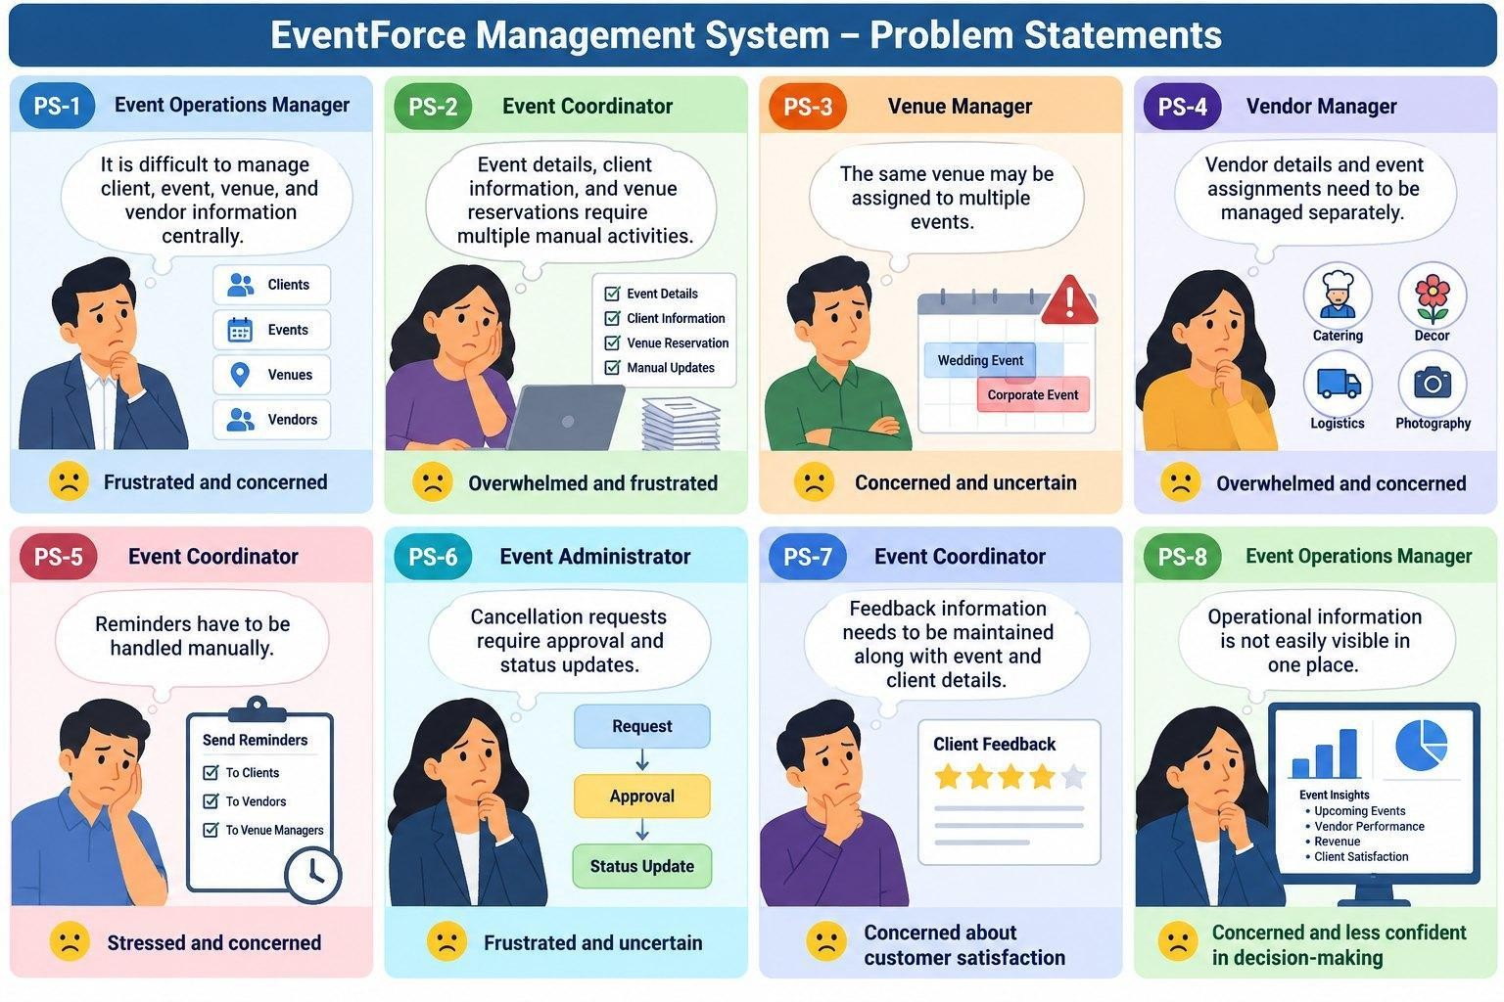
Figure 2.1 – Customer Problem Statements

Empathy Map Canvas
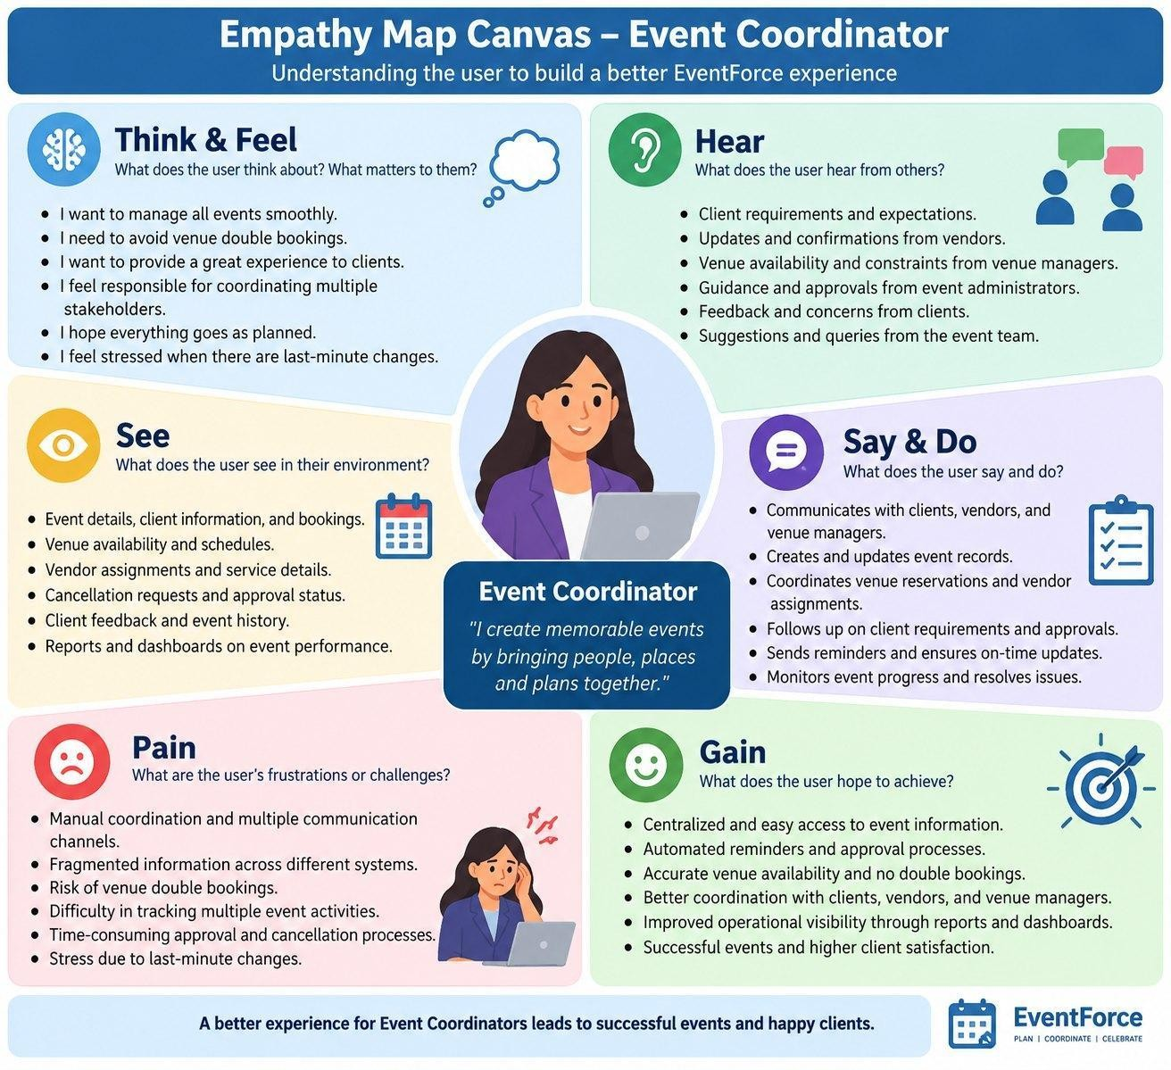
Figure 2.2 – Empathy Map Canvas: Event Coordinator
User Persona: Event Coordinator Role: Event Coordinator
Primary Responsibility: Manage event bookings, client requirements, venue reservations,
vendor coordination, reminders, and event status updates.
- Think & Feel: Wants to manage events smoothly, avoid booking conflicts, and provide a reliable experience to clients.
- Hear: Receives requirements and updates from clients, vendors, venue managers, and event administrators.
- See: Event details, client information, venue availability, vendor assignments, cancellations, and feedback.
- Say & Do: Coordinates with stakeholders, updates event records, manages bookings, follows up on requirements, and monitors event progress.
- Pain: Manual coordination, fragmented information, venue double-booking risks, and difficulty tracking multiple event activities.
- Gain: Centralized event information, automated reminders and processes, accurate venue availability, better coordination, and improved operational visibility.

Brainstorming & Idea Prioritization
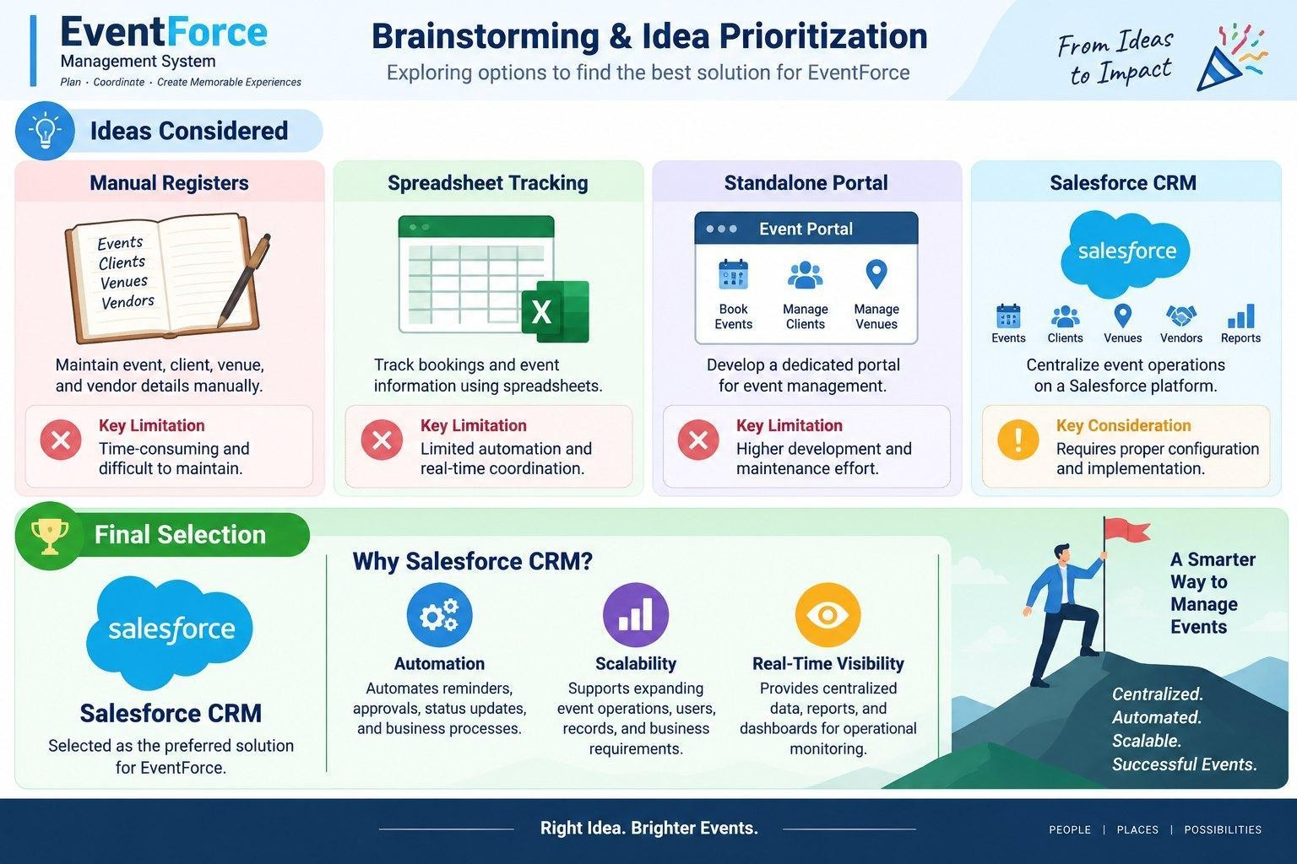
Figure 2.3 – Brainstorming & Idea Prioritization

Ideas Considered

Idea | Approach | Key Limitation
Manual Registers | Maintain event, client, venue, and vendor details manually | Time-consuming and difficult to maintain
Spreadsheet Tracking | Track bookings and event information using spreadsheets | Limited automation and real-time coordination
Standalone Portal | Develop a dedicated portal for event management | Higher development and maintenance effort
Salesforce CRM | Centralize event operations on a Salesforce platform | Requires proper configuration and implementation

Final Selection
Salesforce CRM selected due to:
- Automation – Automates reminders, approvals, status updates, and business processes.
- Scalability – Supports expanding event operations, users, records, and business requirements.
- Real-Time Visibility – Provides centralized data, reports, and dashboards for operational monitoring.
Decision: Salesforce CRM provides the best fit for creating a centralized, automated, and scalable EventForce Management System.

REQUIREMENT ANALYSIS PHASE

Customer Journey Map

Stage | Customer Journey Stage | What Happens
1 | Event Enquiry & Client Registration | Client requirements and contact details are captured in Salesforce.
2 | Event Planning & Booking | Event details such as event type, date, budget, and status are created and managed.
3 | Venue Selection & Reservation | Suitable venues are identified, availability is checked, and reservations are managed while preventing double bookings.
4 | Vendor Coordination | Vendors and required services are assigned to events and their availability/status is coordinated.
5 | Event Confirmation & Communication | Confirmed events trigger automated communication, including reminders sent to clients before the event.
6 | Event Execution & Monitoring | Event progress and operational information are monitored through Salesforce records, reports, and dashboards.
7 | Cancellation & Approval | Cancellation requests are submitted through the approval process, with appropriate status updates and notifications.
8 | Feedback & Closure | Client feedback is captured after the event, and completed events are updated for operational tracking and future analysis.
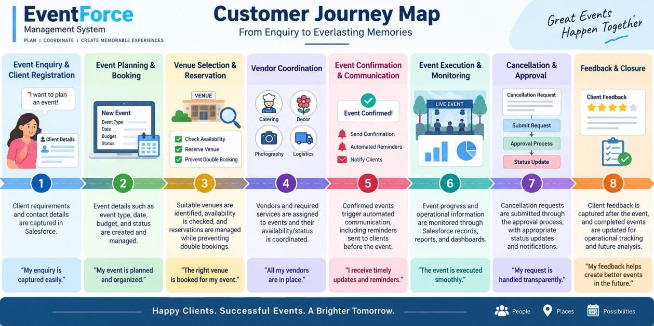
Figure 3.1 – Customer Journey Map

Solution Requirements

Functional Requirements

FR No | Requirement
FR-1 | Event management
FR-2 | Client management
FR-3 | Venue management
FR-4 | Vendor management
FR-5 | Event–vendor assignment
FR-6 | Venue availability & double-booking prevention
FR-7 | Automated event reminders
FR-8 | Event cancellation approval
FR-9 | Feedback management
FR-10 | Reports & dashboards
FR-11 | Event status automation
FR-12 | Data migration through Data Import Wizard

Non-Functional Requirements

NFR | Description
Usability | Lightning App for easy event management and navigation
Security | Profile-, role-, and permission-based access control
Reliability | Accurate automation, approvals, and venue booking validation
Performance | Efficient processing of event and operational data
Availability | Cloud-based Salesforce access for authorized users
Scalability | Supports growing events, clients, vendors, venues, and users
Maintainability | Flows, Apex, validation rules, and security can be monitored and updated
Data Integrity | Validation and controlled data migration to maintain accurate records

Data Flow Diagram
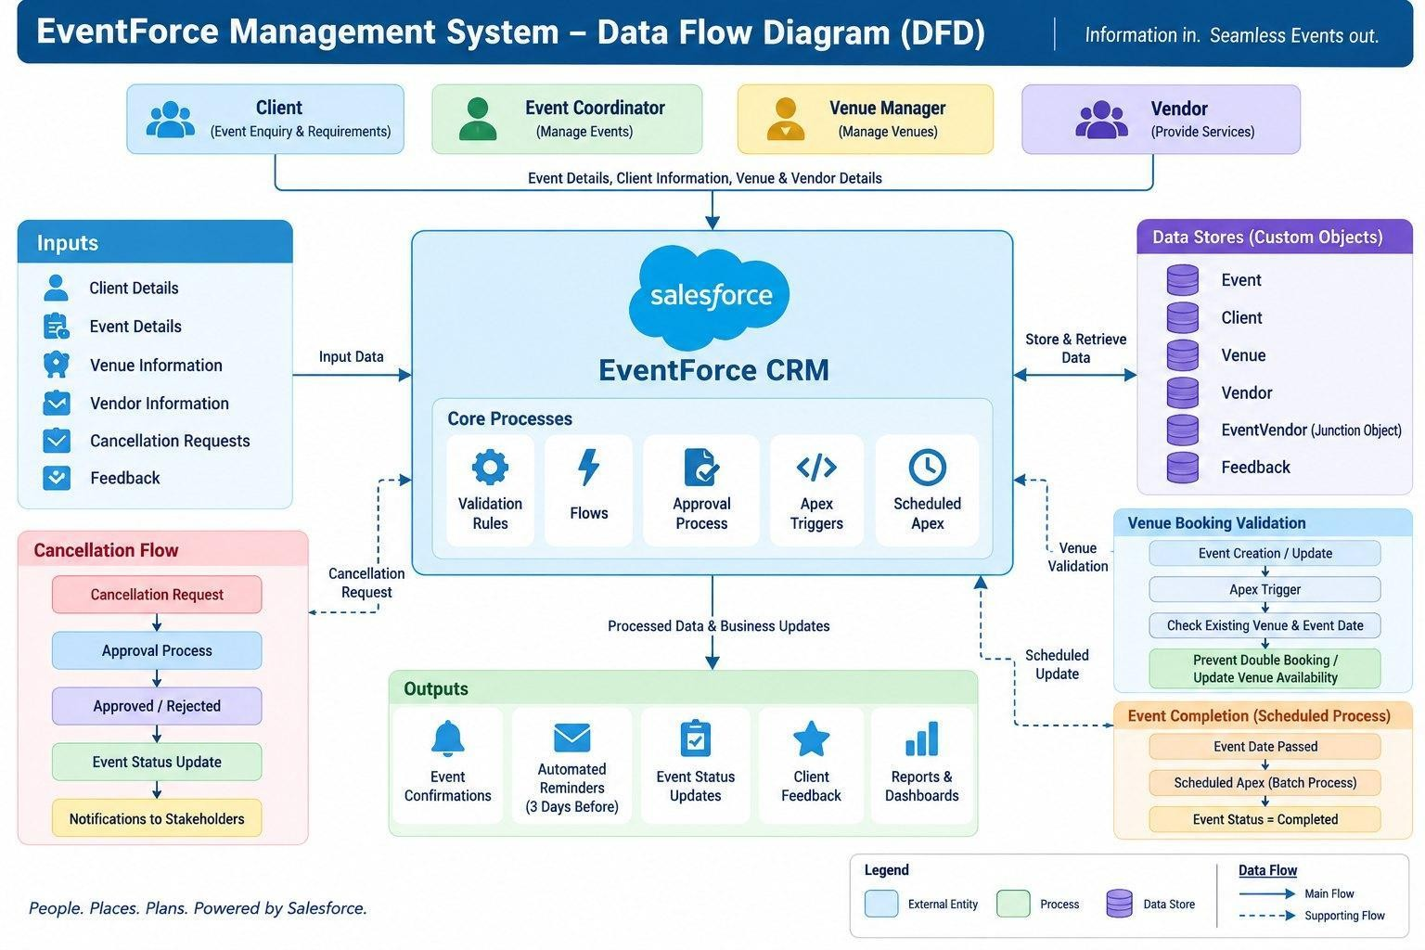

Flow:
Figure 3.2 – Data Flow Diagram (DFD)

Client / Event Team
↓
Enter Client & Event Details
↓
Salesforce EventForce System
↓
Validate & Store Data
↓
Event, Client, Venue & Vendor Records
↓
Check Venue Availability
↓
Assign Venue & Vendors
↓
Confirm Event
↓
Automated 3-Day Reminder
↓
Event Execution & Status Updates
↓
Feedback Collection
↓
Reports & Dashboards

Supporting Flows
- Cancellation Request: Event Coordinator → Cancellation Request → Approval Process → Approved / Rejected → Event Status Update → Notifications
- Venue Booking Validation: Event → Apex Trigger → Venue Status Helper → Check Existing Venue & Event Date → Prevent Double Booking / Update Venue Availability
- Event Completion: Event Date Passed → Scheduled Apex → Batch Process → Event Status = Completed

Simple DFD Representation
Clients / Event Coordinators / Vendor Managers / Venue Managers
↓
Salesforce CRM – EventForce
↓
Custom Objects: Event | Client | Vendor | Venue | Feedback | EventVendor
↓
Automation & Business Logic: Flows | Approval Process | Apex
↓
Operational Data & Status Updates
↓
Reports & Dashboards
↓
Event Operations & Decision Making

Technology Stack

Layer | Technology
Platform | Salesforce CRM / Developer Edition
UI | Salesforce Lightning App
Database | Salesforce Custom Objects
Business Logic | Salesforce Flows, Formula Fields, Validation Rules
Approval | Salesforce Approval Process
Automation | Record-Triggered Flows, Apex Triggers
Processing | Batch Apex, Scheduled Apex
Security | Profiles, Roles, Permission Sets, Sharing Rules, OWD
Reporting | Reports & Dashboards

PROJECT DESIGN PHASE

Problem–Solution Fit
The EventForce Management System provides a strong fit between identified event-management problems and Salesforce capabilities. The solution combines custom data structures, automation, Apex business logic, approval processes, security controls, and reporting to address the operational challenges of event planning and coordination.

Problem | Solution – EventForce Salesforce System | Fit / Benefit
Client, event, venue, and vendor information is difficult to manage centrally | Custom Salesforce objects for Event, Client, Venue, Vendor, Feedback, and EventVendor | Centralized and structured event data
Event booking requires multiple manual activities | Salesforce Flows and automated processes | Reduces manual effort and improves process efficiency
Risk of venue double booking | Apex Trigger and VenueStatusHelper | Validates venue availability and prevents double bookings
Vendor coordination is difficult to track | EventVendor junction object and Vendor records | Supports event–vendor assignment and coordination
Clients may not receive timely event reminders | 3-Day Reminder Flow | Automates reminder communication before confirmed events
Cancellation requests require controlled processing | Event_Cancellation_Process Approval Process | Provides structured approval and status updates
Client feedback needs to be connected with events | Feedback object with Event and Client relationships | Enables organized feedback management
Operational information is difficult to monitor | Reports and EventForce Operations Dashboard | Provides better visibility for monitoring and decisions
Different users require different levels of access | Profiles, Roles, Permission Sets, OWD, and Sharing Rules | Provides controlled and secure data access

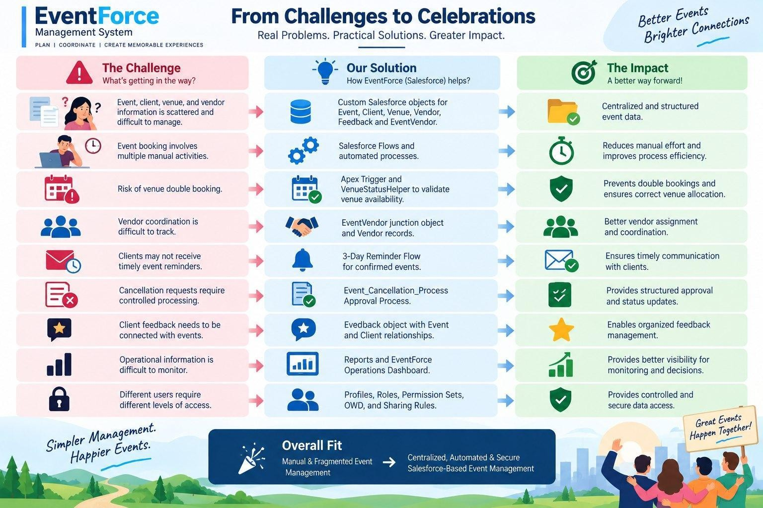
Figure 4.1 – Problem–Solution Fit

Proposed Solution

Parameter | Description
Problem | Manual and fragmented event management
Solution | Salesforce CRM
Innovation | Automated event reminders, venue validation, and cancellation approvals
Impact | Faster event coordination and improved operational visibility
Business Model | Centralized event planning and management
Scalability | Supports growing events, clients, vendors, venues, and users

Solution Architecture
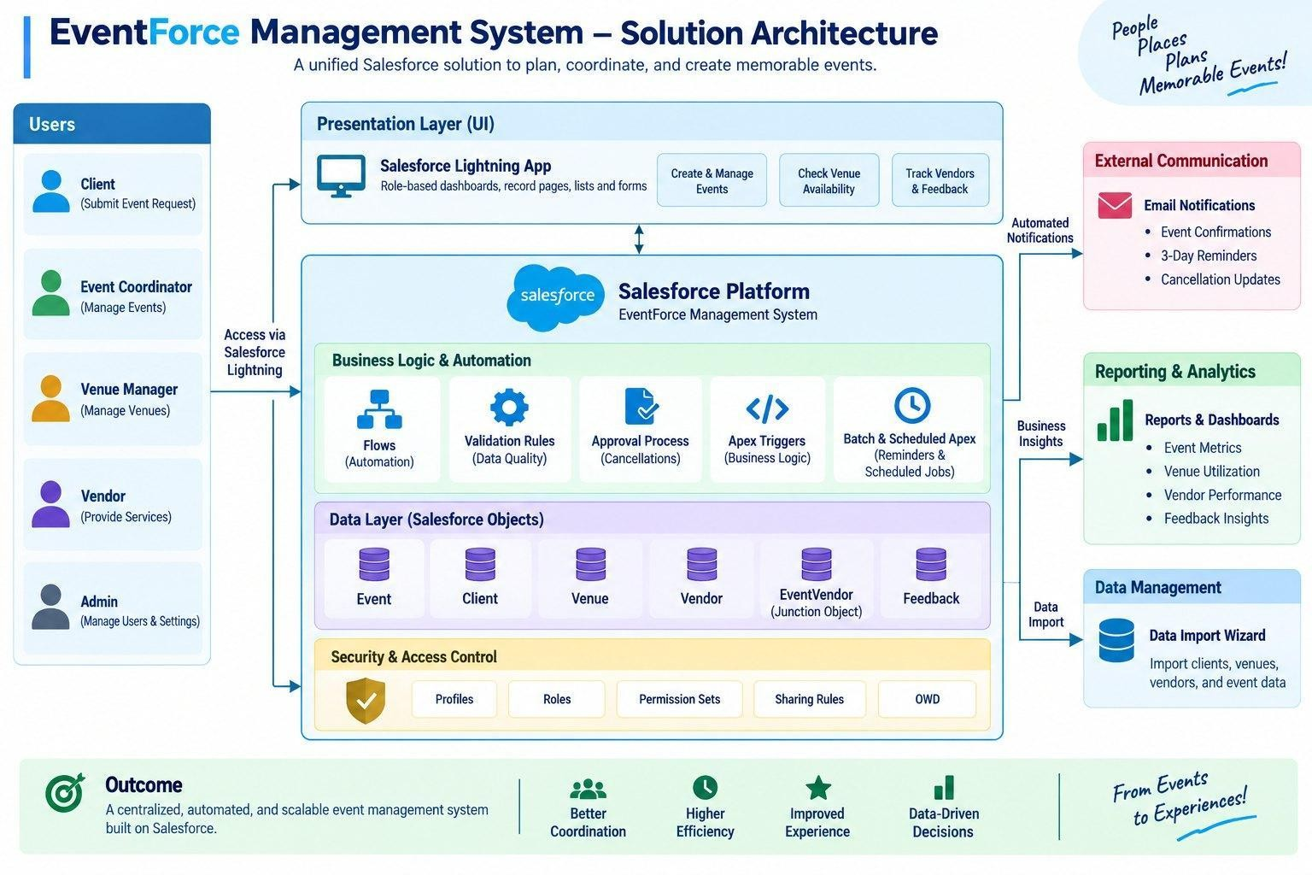
Figure 4.2 – Solution Architecture

Components:
- Event Object
- Client Object
- Vendor Object
- Venue Object
- EventVendor Junction Object
- Feedback Object
- Validation Rules
- Formula Fields
- Flows
- Approval Process
- Apex Triggers

- Apex Classes
- Batch Apex
- Scheduled Apex
- Profiles & Roles
- Permission Sets & Sharing Rules
- Data Import Wizard
- Lightning App
- Reports
- Dashboards

PROJECT PLANNING & SCHEDULING

Project Planning
- Agile methodology
- Epics → Stories → Story Points
- Sprint-based execution
- Velocity calculation used for estimation

Product Backlog, Sprint Schedule, and Estimation

Sprint | Functional Requireme nt (Epic) | User Story No. | User Story / Task | Story Point s | Priori ty | Team Member
Sprint-1 | Event Managemen t | US-01 | As an Event Coordinator, I want to create events with type, date, and status so that event information is standardized. | 3 | High | Pratiksha S
Sprint-1 | Client & Venue Managemen t | US-02 | As an Event Coordinator, I want to associate a client and venue with an event so that coordination is centralized. | 5 | High | Sowmiya A
Sprint-2 | Vendor Managemen t | US-03 | As a Vendor Manager, I want to assign multiple vendors to an event so that services can be coordinated. | 5 | High | Aswin S
Sprint-2 | Notification s & Automation | US-04 | As a Client, I want timely event reminders so that I know when my event is approaching. | 3 | High | Lokesh J
Sprint-3 | Approval Managemen t | US-05 | As an Event Coordinator, I want cancellation requests to follow an approval process so that cancellations are controlled. | 5 | High | Shalini A
Sprint-3 | Venue Managemen t & Apex | US-06 | As a Venue Manager, I want double bookings prevented so that venue schedules remain accurate. | 8 | High | Pratiksha A
Sprint-4 | Security & Access Control | US-07 | As an Event Administrator, I want role-based access so that users see only appropriate information. | 5 | High | Sowmiya A
Sprint-4 | Reports & Dashboards | US-08 | As Management, I want reports and dashboards so that event operations can be monitored. | 5 | Mediu m | Aswin S

Project Tracker, Velocity & Burndown Chart

Sprint | Total Story Points | Duratio n | Sprint Start Date | Sprint End Date (Planned) | Story Points Completed | Sprint Release Date (Actual)
Sprint-1 | 20 | 6 Days | 28 Sep 2026 | 03 Oct 2026 | 20 | 29 Oct 2022
Sprint-2 | 20 | 6 Days | 31 Oct 2026 | 03 Oct 2026

Sprint | Total Story Points | Duratio n | Sprint Start Date | Sprint End Date (Planned) | Story Points Completed | Sprint Release Date (Actual)
Sprint-3 | 20 | 6 Days | 27 Sep 2026 | 03 Oct 2026
Sprint-4 | 20 | 6 Days | 2 Oct 2026 | 03 Oct 2026

Velocity: the team planned 20 story points per sprint (80 story points over 4 sprints of 6 days each), giving an average velocity of 20 story points per sprint, or about 3.33 story points per day (20 ÷ 6).

PROJECT DEVELOPMENT PHASE

Phase 1: Requirement Analysis & Planning
Build an EventForce Management System in Salesforce to help event planners manage client bookings, vendor coordination, venue reservations, and feedback collection — all within a single CRM platform. The system automates key processes such as event scheduling, cancellation approvals, and client reminders, while providing real-time visibility through reports and dashboards.
This phase defined what the system must do, who will use it and in what order it would be built. The solution was scoped as a single Salesforce application that manages client bookings, vendor coordination, venue reservations and feedback, automates event scheduling, cancellation approvals and client reminders, and exposes real-time reports and dashboards.

Functional Scope
      - Custom objects: Event, Client, Vendor, Venue, Feedback and Event Vendor (Junction Object).
      - Relationship modeling: Lookup, Master-Detail and Many-to-Many (Event ↔ Vendor).
      - Automation using Flows for reminders, feedback notifications and approval updates.
      - Validation Rules and Formula Fields for accurate data entry and event-budget calculation.
      - Approval Processes for event cancellation requests with email alerts to coordinators and clients.
      - Profiles, Roles and Permission Sets to manage user-level access and security.
      - Reports and Dashboards for event summary, vendor performance and upcoming-event insights.

Stakeholder Mapping
Stakeholders were mapped to Salesforce roles and profiles as shown below.

Stakeholder | Salesforce Role | Salesforce Profile | Primary Needs
Event Administrator | Event Admin | Event Admin | Full system oversight, security and monitoring
Event Coordinator | Event Coordinator | Event Coordinator | Event scheduling, client communication, approvals
Vendor Manager | Vendor Manager | Vendor Manager | Vendor records and assigned services
Client | Client | Client Profile | View own events, submit feedback

Execution Roadmap

Step | Activity | Outcome
1 | Object & Field Setup | Event, Client, Vendor, Venue, Feedback and Event Vendor objects created
2 | Automation Flows | Record-triggered flow for event reminders
3 | Validation Rules & Formula Fields | Data accuracy and budget calculations enforced
4 | Profiles, Roles, Permission Sets | User access and record visibility configured
5 | Approval Process | Event cancellation workflow with notifications
6 | Apex Classes & Triggers | Venue availability updates and double-booking prevention
7 | Reports & Dashboards | Analytics for upcoming events and performance

Phase 2: Backend Development & Configurations
The backend phase built the functional engine of the system. Declarative tools (Record-Triggered Flows, Validation Rules, Formula Fields and Approval Processes) automated booking confirmations, reminders and cancellation approvals, while Apex classes and triggers handled advanced logic such as venue availability updates and double-booking prevention. The phase was executed through the milestones described below.

Milestone 1 – Salesforce Developer Account
Salesforce is a customer success platform used to sell, service, market, analyze and connect with customers. A free Developer Edition org was created to build and test the entire project.

Activity 1: Creating the Developer Account
- Open https://developer.salesforce.com/signup.
- Enter First Name, Last Name and Email; select Role as Developer; enter the college name as Company; Country as India; and the Postal Code.
- Enter a unique Username in email format (for example, username@organization.com). It need not be a real mailbox.
- Click Sign me up.

Activity 2: Account Activation
- Open the verification email (it may take 5–10 minutes) and click Verify Account.
- Set a password and answer the security question, then click Change Password.
- The user is redirected to the Salesforce Setup home page.

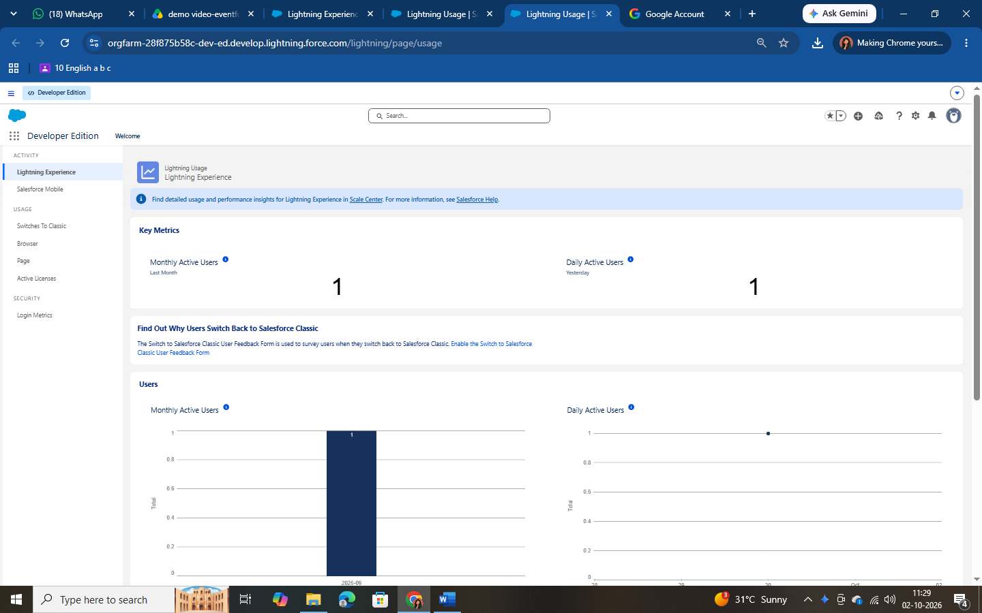

Data Architecture
The data model consists of five primary custom objects and one junction object. An object is a database table that stores organization-specific data; it consists of fields (columns) and records (rows).

Object | API Name | Record Name | Purpose
Event | Event c | Event Name (Text) | Stores event details, status and budget
Client | Client c | Client Name (Text) | Stores client contact information
Vendor | Vendor c | Vendor Name (Text) | Stores vendor details and services
Venue | Venue c | Venue Name (Text) | Stores venue details and availability
Feedback | Feedback c | Feedback ID (Auto Number, F-{0000}) | Stores client ratings and comments
Event Vendor | EventVendor c | Auto-generated | Junction object linking Event ↔ Vendor

Milestone 2 – Creating Custom Objects
Each object was created from Setup → Object Manager → Create → Custom Object. The Event object was created with the following options:
      - Label: Event; Plural Label: Events; Record Name: Event Name; Data Type: Text.
      - Optional Features: Allow Reports, Allow Activities and Track Field History.
      - Deployment Status: Deployed; Search Status: Allow Search.
      - Object Creation Options: Add Notes and Attachments related list to the default page layout.

The Client, Vendor and Venue objects were created in the same way (Record Name of Text type, with Allow Reports, Allow Search and the Notes and Attachments related list enabled). The Feedback object uses an Auto Number record name with display format F-{0000} and a starting number of 0. The Event Vendor junction object was created separately (see Relationships under Section 6.2.2).

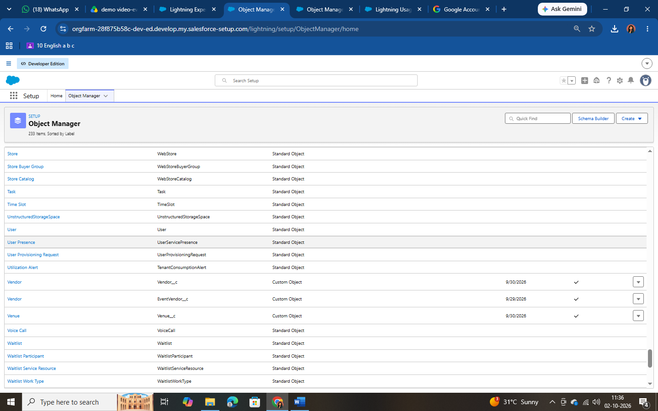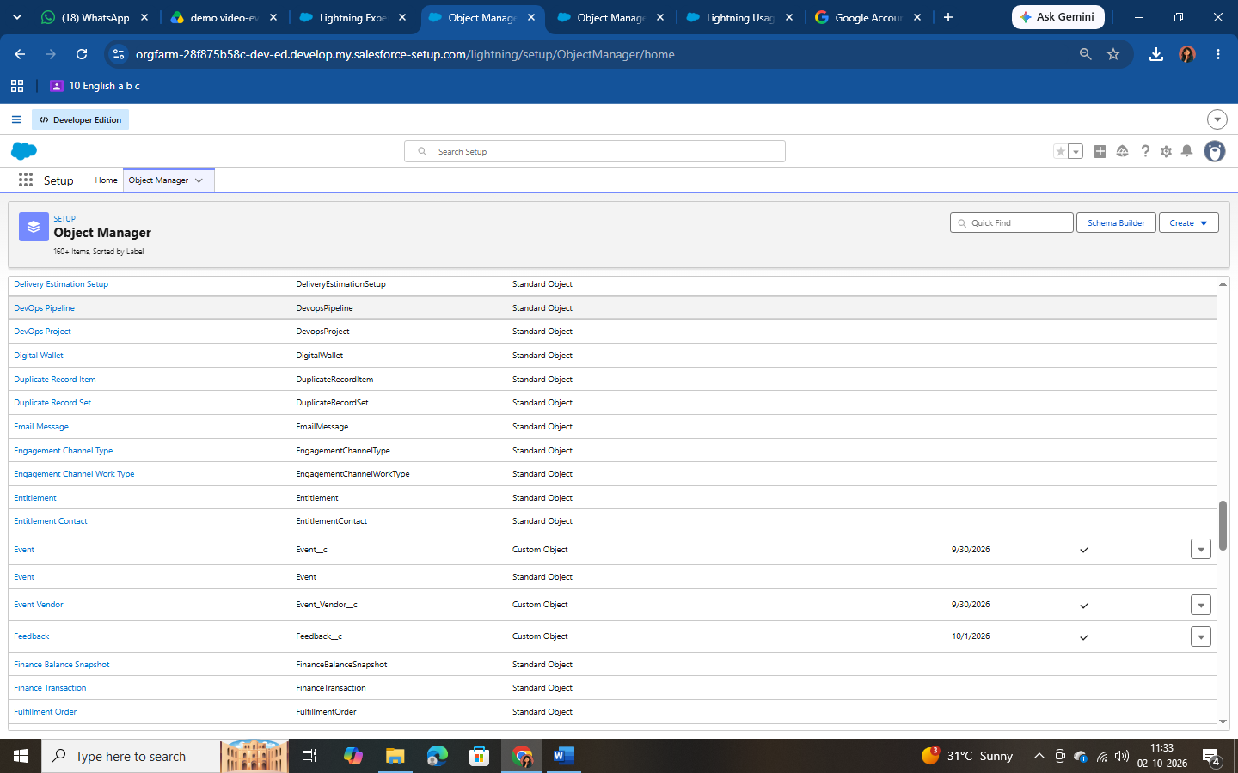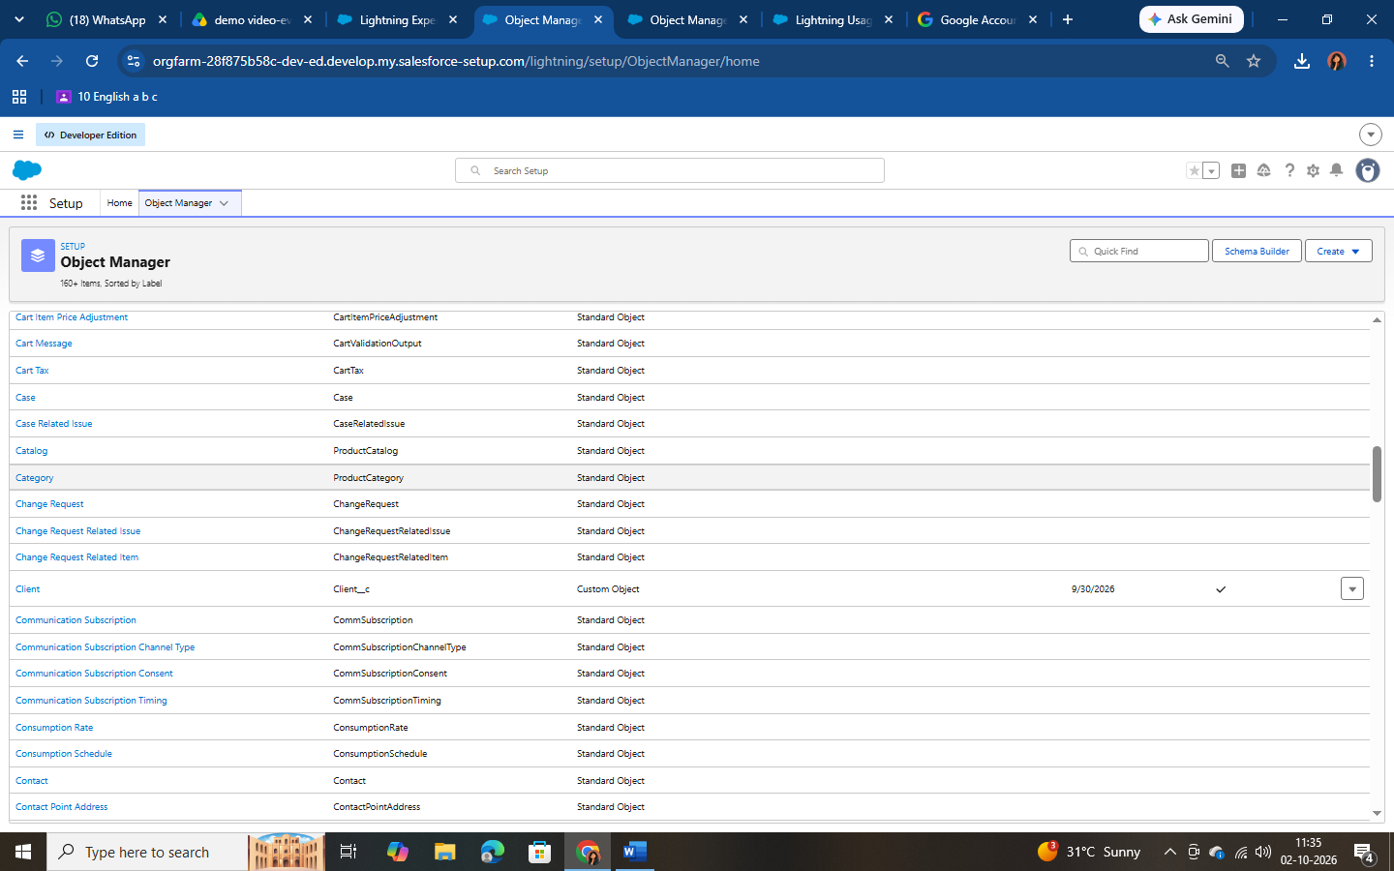

Milestone 3 – Custom Tabs
Tabs display object data at a glance. A custom object tab was created for each object using Setup → Tabs → Custom Object Tabs → New. For each of Event, Client, Vendor, Venue and Feedback: select the object, choose a Tab Style icon, and accept the defaults (Next, Next, Save).

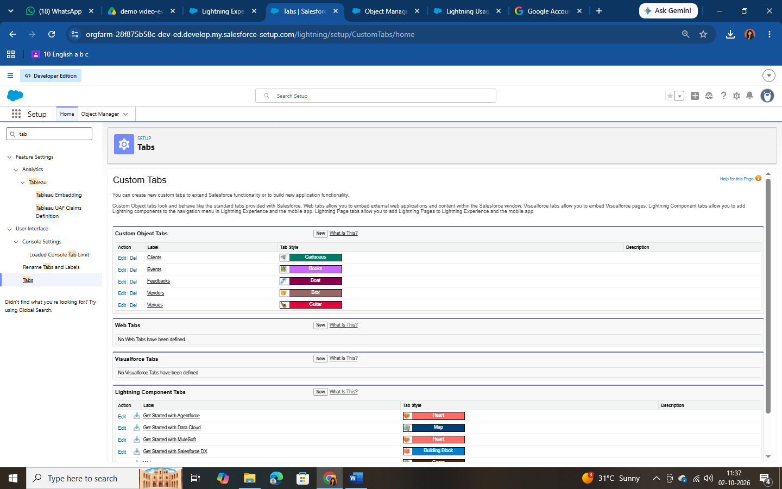

Milestone 4 – Fields
Custom fields were added to each object from Object Manager → Fields & Relationships → New, choosing the appropriate data type.

Object | Field Label | Data Type | Values / Notes
Event | Event Type | Picklist | Wedding, Corporate, Birthday, Anniversary, Festival, Concert, Other
Event | Event Date | Date | Date of the event
Event | Event Status | Picklist | Planned, Confirmed, Completed, Pending Cancellation, Canceled, Rejected
Event | Event Budget | Formula (Currency) | Calculated from Event Type (see Section 6.2.3)
Client | Email | Email | Client email address
Client | Phone | Phone | Client contact number
Client | Address | Text Area | Client address
Client | Country | Picklist | India, Philippines, Saudi Arabia, USA, Switzerland, Thailand, Maldives, Dubai, Sri Lanka, Bangkok, Singapore, Myanmar, France, Nepal
Client | City | Picklist | Hyderabad, Mumbai, Delhi, Bangalore, Chennai, Alaminos, Angeles City, Palayan, Quezon City, San Juan, Riyadh, Jeddah, Tayma, Dammam, Medina, New York, Los Angeles, Chicago, Houston, Columbus, Geneva, Basel, Lausanne, Bern, Lucerne
Vendor | Service Type | Multi-Select Picklist | Catering, Decor, Photography, Videography, Lighting, Stage Setup,

Object | Field Label | Data Type | Values / Notes
 |  |  | Makeup Artist, DJ/Music, Transportation, Hosting/Anchor
Vendor | Email | Email | Vendor email address
Vendor | Phone | Phone | Vendor contact number
Vendor | Status | Picklist | Available, Booked, Cancelled
Venue | Address | Text Area | Venue address
Venue | Location | URL | Map link of the venue
Venue | Capacity | Number | Maximum guest capacity
Venue | Availability Status | Picklist | Available, Reserved, Not Available
Feedback | Rating | Picklist | 1, 2, 3, 4, 5
Feedback | Comments | Long Text Area | Client comments
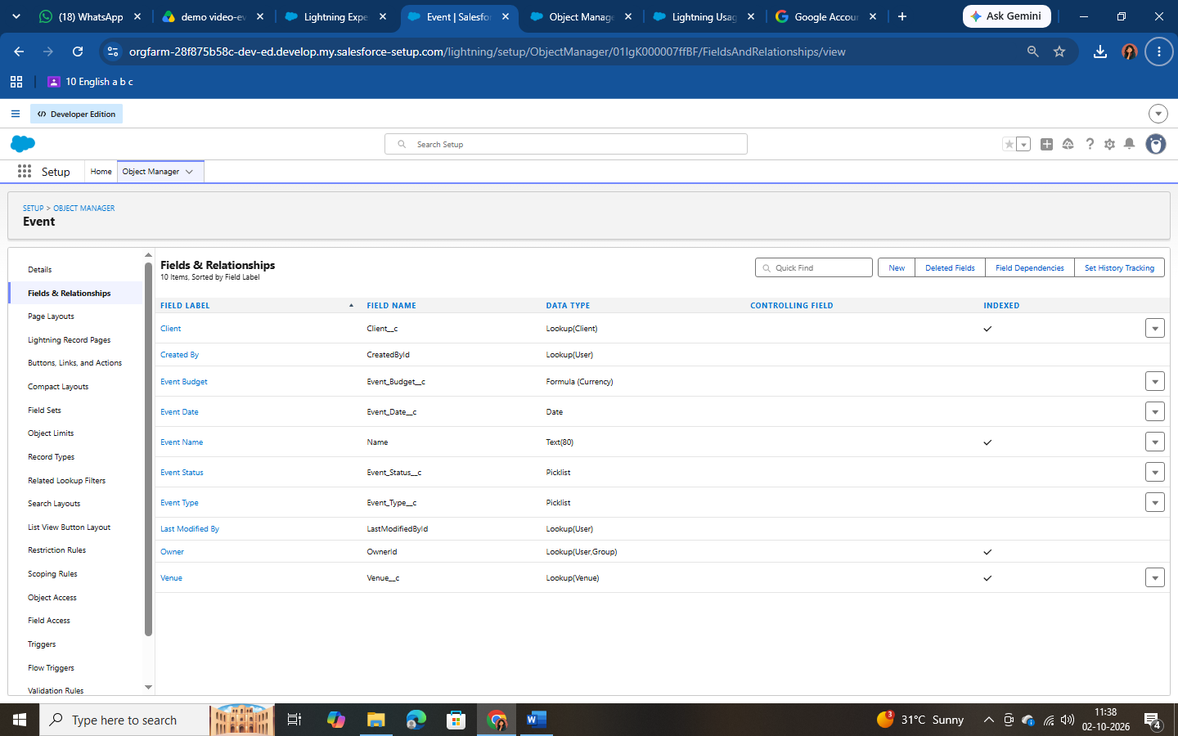

Relationships
Relationships connect the objects. Lookup relationships link loosely coupled records, whereas Master-Detail relationships create a tight parent–child dependency. Salesforce does not allow a direct many-to-many relationship, so the Event Vendor junction object with two Master-Detail relationships was created to link Event and Vendor.

Relationship | Type | Field Label
Event → Client | Lookup | Client
Event → Venue | Lookup | Venue

Relationship | Type | Field Label
Feedback → Event | Lookup | Event
Feedback → Client | Lookup | Client
EventVendor → Event | Master-Detail | Event
EventVendor → Vendor | Master-Detail | Vendor

Creating the Lookup Relationships
- From Setup open Object Manager and select the Event object.
- Click Fields & Relationships → New → Lookup Relationship → Next.
- Choose the related object (Venue), click Next, enter the field label and continue with Next, Next, Next and Save.
- Repeat to add the Client lookup on Event, and the Event and Client lookups on Feedback.

Creating the Many-to-Many Relationship (Event ↔ Vendor)
- Go to Object Manager → Create → Custom Object. Label: Event Vendor; Object Name: EventVendor c.
- On the Event Vendor object click Fields & Relationships → New → Master-Detail Relationship. Choose Event as the related object, label it Event and click Save & New.
- Create a second Master-Detail Relationship to Vendor with the label Vendor and click Save.

Lookup Filter (Feedback → Event)
Scenario: when a Client is selected on a Feedback record, the Event lookup must show only that client’s events. For example, if Ramesh is selected, only Ramesh’s events should appear.
- Open Object Manager → Feedback → Fields & Relationships → Event (Event c) and click Edit.
- In the Lookup Filter section click Show Filter Settings.
- Build the criteria: Event: Client (Client c) equals Field → Feedback: Client (Client c).
- Tick Enable this filter and click Save.

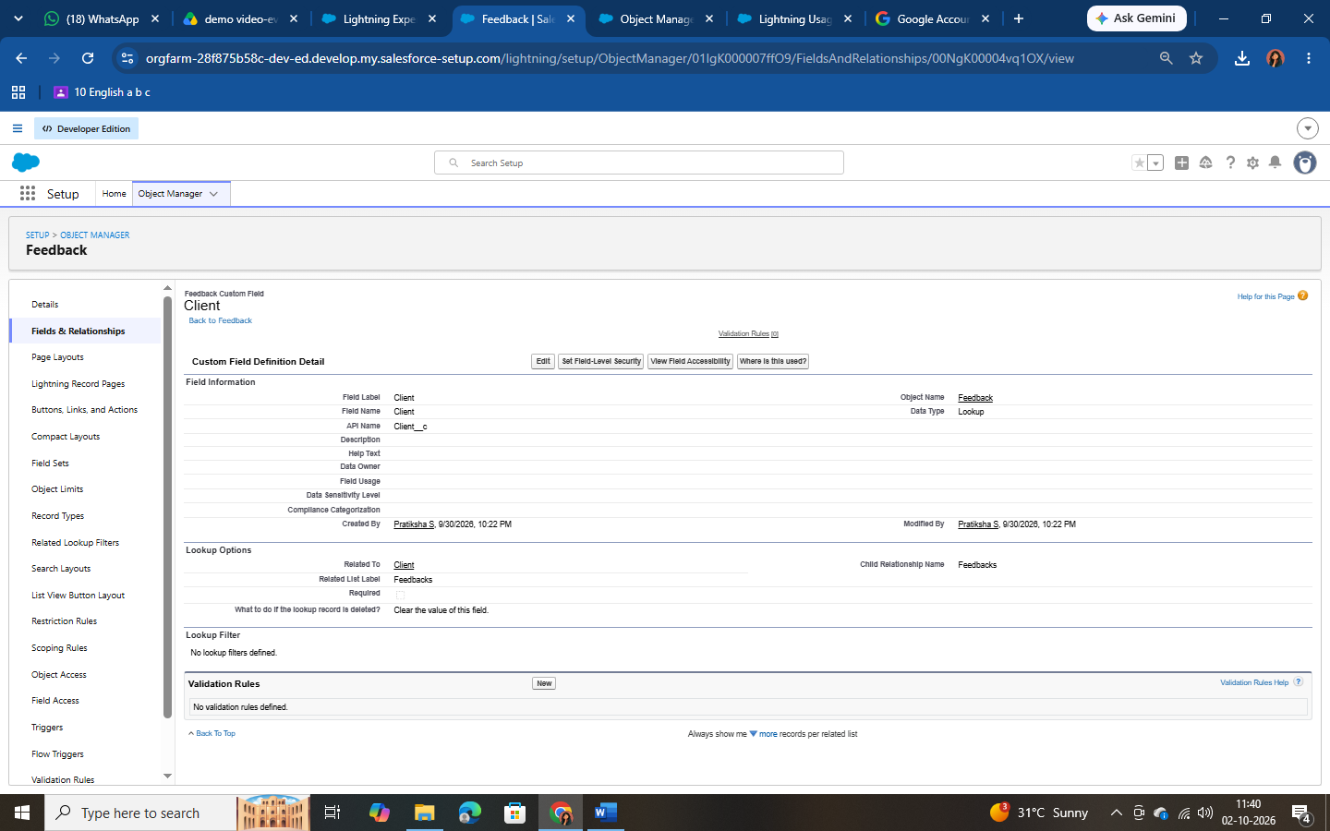

Formula Field – Event Budget
The Event Budget is a Formula field (return type Currency) on the Event object that derives the budget automatically from the Event Type, removing manual entry errors. Steps: Fields & Relationships → New → Formula → Label “Event Budget” → Return type Currency → insert the formula below → Check Syntax → Next, Next, Save.
CASE(
TEXT(Event_Type c), "Wedding", 50000,
"Corporate", 30000,
"Birthday", 10000,
"Anniversary", 20000,
"Festival", 60000,
"Concert", 40000,
"Other", 15000,
0
)

Event Type | Budget
Wedding | 50,000

Event Type | Budget
Corporate | 30,000
Birthday | 10,000
Anniversary | 20,000
Festival | 60,000
Concert | 40,000
Other | 15,000
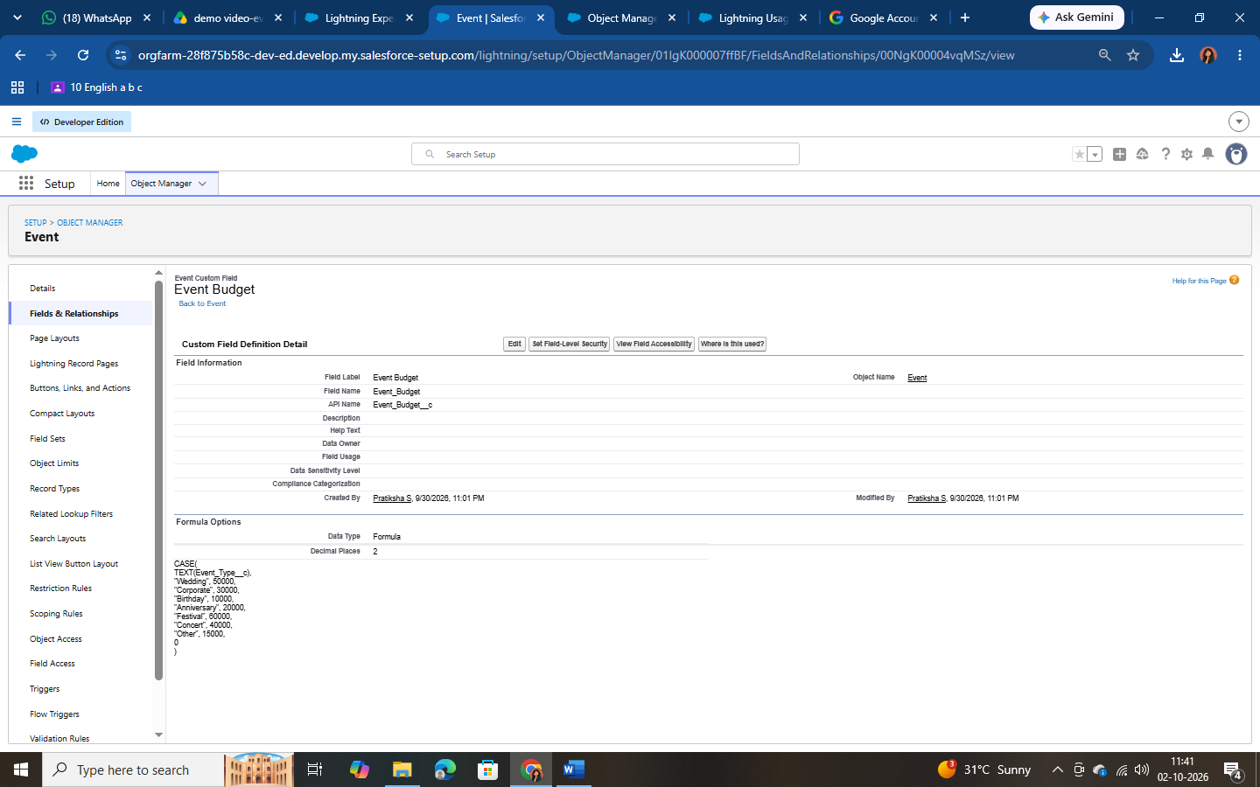

Milestone 5 – Validation Rules
Validation rules run when a user saves a record and block the save if the data does not meet the defined criteria. A validation rule was created on the Client object to ensure that only properly formatted email addresses are stored.
- Go to Setup → Object Manager → Client → Validation Rules → New.
- Rule Name: Email_Valid_Address; tick Active.
- Enter the Error Condition Formula shown below.
- Error Message: “Please Enter Valid Email Address”; Error Location: Field → Email.
Click Save.
NOT(REGEX(Email c, "^[a-zA-Z0-9._]+@[a-zA-Z0-9.]+\\.[a-zA-Z]{2,}$"))

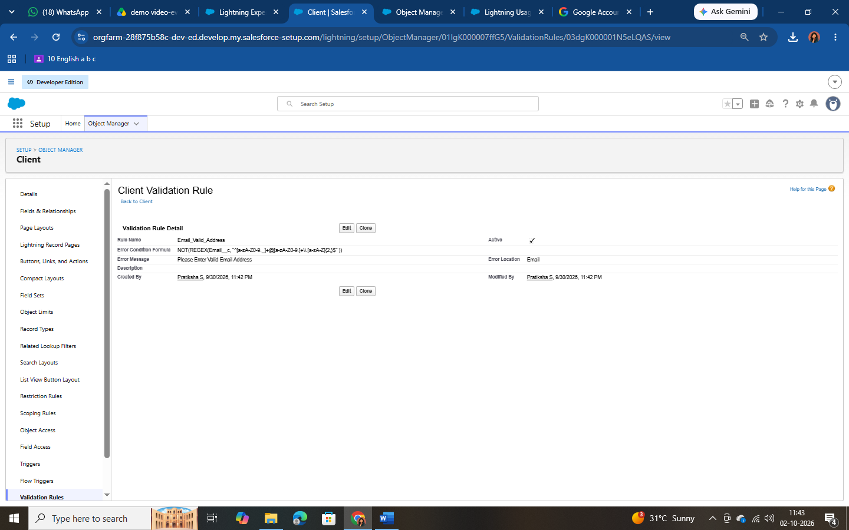

Milestone 6 – Approval Process (Event Cancellation)
The cancellation approval process ensures that an event is canceled only after manager approval, with automatic notifications to all parties. Note: the Profiles, Roles and Users milestones (Sections 6.4.1–6.4.3) must be completed before implementing the approval process.

Step A – Classic Email Templates
Four Text-type Classic Email Templates were created under Setup → Email Templates → Classic Email Templates → New Template (folder: Unfiled Public Email Templates, encoding UTF-8).

Template Name | Subject | Used For
Event Cancellation Request Notification | Approval Request: Cancel Event  {!Event c.Name} | Approval request submission alert
Email to Client After Cancellation | Event Cancellation Notice –  {!Event c.Name} | Informs client once the cancellation is approved
Approval Notification to Event Owner | Event Cancellation Approved:  {!Event c.Name} | Owner notification on approval
Rejection Notification to Event Owner | Event Cancellation Rejected:  {!Event c.Name} | Owner notification on rejection

Sample Template Body – Event Cancellation Request Notification
Hello!

An approval request has been submitted to cancel the event:
- Event Name: {!Event c.Name}
- Event Date: {!Event c.Event_Date c}

Thank you,
EventForce Management System

Sample Template Body – Approval Notification to Event Owner
Hello {!Event c.OwnerFullName},

Your cancellation request for the event {!Event c.Name} has been approved. Event Date: {!Event c.Event_Date c}
The event status has been updated to Canceled.

Thank you,
EventForce Management System
The Rejection Notification template follows the same structure, stating that the request has been rejected and that the event status has been reverted to Confirmed. The Email to Client After Cancellation template informs the client that the event (name and date) has been canceled and invites them to contact the team with any questions.

Step B – Creating the Approval Process
- Setup → Approval Processes → select object Event → Create New Approval Process
→ Use Standard Setup Wizard.
- Basic Settings: Name = Event_Cancellation_Process; unique name auto-fills.
- Entry Criteria: Criteria are met → Event: Event Status equals Pending Cancellation.
- Select Approver: automatically assign using a user or queue (a specific user / manager of the submitting user; ensure a manager is set on the User record).
- Email Template: Event Cancellation Request Notification.
- Approval Page Fields: Event Name, Owner, Client, Last Modified By, Created By, Event Budget, Event Date, Event Status, Event Type, Venue.
- Initial Submitters: Event Owner. Click Save.

Step C – Actions
Stage | Action Type | Configuration
Initial Submission | Email Alert | Alert – Event Cancellation Request; template: Event Cancellation Request Notification; recipient: Role – Event Coordinator; From: Current User’s Email
Final Approval | Field Update | Name: Event Status Update; Field: Event Status; New Value: Canceled
Final Approval | Email Alert | Alert – Cancellation Approved; template: Approval Notification to Event Owner; recipient: Event Owner
Final Rejection | Email Alert | Alert – Cancellation Rejected; template: Rejection Notification to Event Owner; recipient: Event Owner
Final Rejection | Field Update | Name: Event Status To Rejected; Field: Event Status; New Value: Rejected

Step D – Approval Step and Activation
- Click Add New Step; Step Name: Manager Review; All records should enter this step; click Next.
- Assign the approver automatically (a specific user / related user) and click Save.
- Open View Approval Process Detail Page and click Activate.

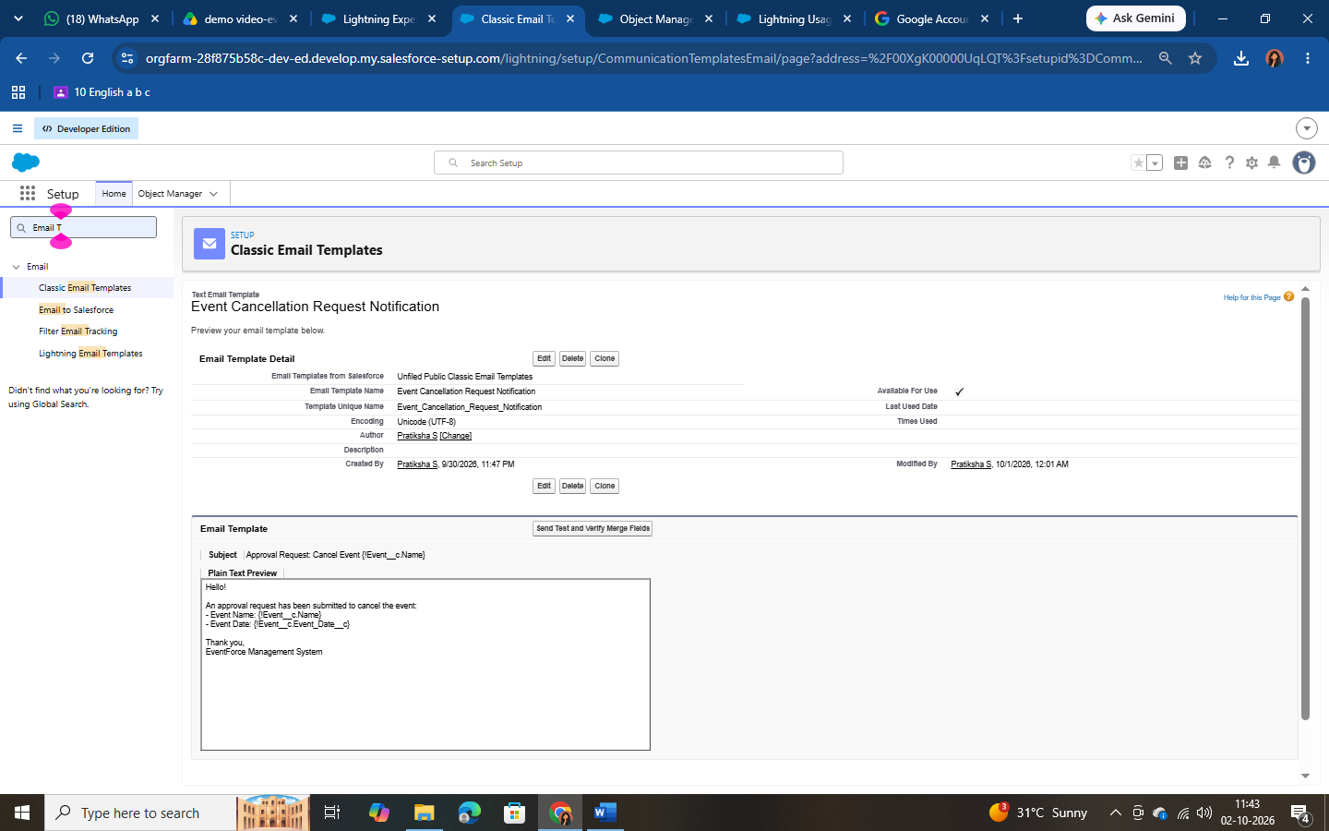

Milestone 7 – Flow: 3-Day Reminder Email to Client
Scenario: when an Event is created or updated with Event Status = Confirmed and has a client with a valid email address, the system automatically sends a reminder email to the client three days before the Event Date.

Flow Configuration
- Setup → Flows → New Flow → Record-Triggered Flow → Create.
- Object: Event; Trigger: A record is created or updated.
- Condition: Event Status equals Confirmed. Optimize the flow for Actions and Related Records; click Done.
- Click Start → Add Schedule Path. Path Name: 3_Days_Before; Time Source: Event c: Event Date; Offset: 3 Days Before.
- Toolbox → New Resource → Text Template. API Name: Subject; Body: “Reminder: Your Event {!$Record.Name} is in 3 days” (plain text).
- Create a second Text Template with API Name Body (content shown below).
- Under the 3_Days_Before path click + → Action → Send Email. Label: Alert_Client_3Day_Reminder.
- Recipient Address List: Client Email; CC Recipient Address List: Event Owner.
- Configure Email Content → Compose Email Content: Subject = Subject resource;
Body = Body resource.
- Click Save, enter Flow Label “Client Reminder - 3 Days Before”, then Save & Activate.

Body Text Template
Hello {!$Record.Client r.Name},

This is a reminder that your event "{!$Record.Name}" will take place on
{!$Record.Event_Date c}.

Venue: {!$Record.Venue r.Name} Type: {!$Record.Event_Type c}

We look forward to seeing you!

- EventForce Team

Figure 6.1 – Record-triggered flow

Milestone 8 – Apex Class & Trigger: Venue Status Update
Scenario: when an Event is created or updated with a Venue, the venue’s Availability Status is set to Reserved when the event is Confirmed, and set back to Available when the event is Canceled. The logic is kept in a helper class and invoked from a thin trigger – a recommended best practice.

Apex Class: VenueStatusHelper
Open Gear Icon → Developer Console → File → New → Apex Class → name it VenueStatusHelper, then enter and save (Ctrl+S):
public with sharing class VenueStatusHelper {
public static void updateVenueStatus(List<Event c> events){ List<Venue c> venues = new List<Venue c>();
for(Event c ev : events){ if(ev.Venue c != null){
if(ev.Event_Status c == 'Confirmed'){

venues.add(new Venue c(Id=ev.Venue c, Availability_Status c='Reserved'));
} else if(ev.Event_Status c == 'Canceled'){ venues.add(new Venue c(Id=ev.Venue c,
Availability_Status c='Available'));
}
}
}
if(!venues.isEmpty()) update venues;
}
}

Apex Trigger: EventTrigger13
File → New → Apex Trigger → Name: EventTrigger13, sObject: Event c:
trigger EventTrigger13 on Event c (after insert, after update) { VenueStatusHelper.updateVenueStatus(Trigger.new);
}

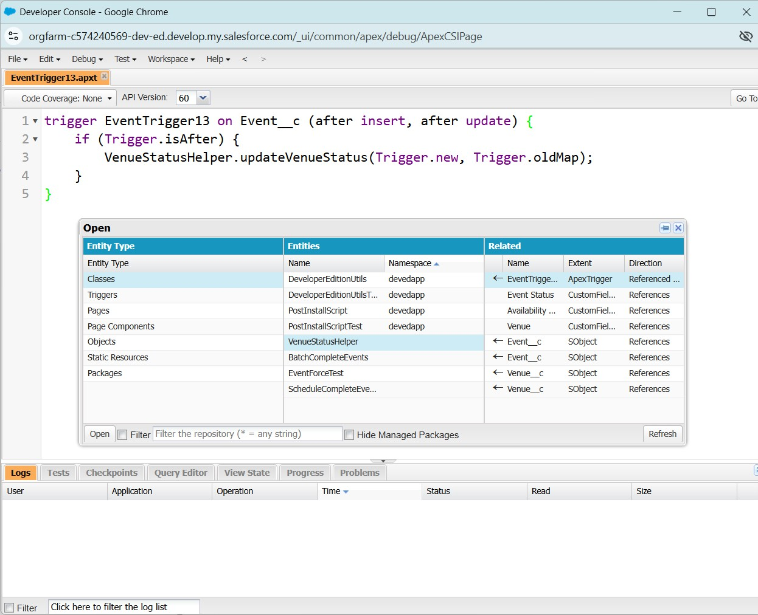

Milestone 9 – Apex Trigger: Prevent Double Booking
Scenario: two events must not be allowed at the same Venue on the same date. The before-insert/before-update trigger collects the venues involved, queries existing events at those venues in a single query (bulk-safe), and raises an error if another event already exists on the same date.
trigger PreventDoubleBooking on Event c (before insert, before update) { Set<Id> venueIds = new Set<Id>();
for(Event c ev : Trigger.new){
if(ev.Venue c != null) venueIds.add(ev.Venue c);
}

Map<Id, List<Event c>> venueEventMap = new Map<Id, List<Event c>>(); for(Event c e : [SELECT Id, Venue c, Event_Date c
FROM Event c WHERE Venue c IN :venueIds]){ if(!venueEventMap.containsKey(e.Venue c)){

venueEventMap.put(e.Venue c, new List<Event c>());
}
venueEventMap.get(e.Venue c).add(e);
}

for(Event c ev : Trigger.new){
if(ev.Venue c != null && venueEventMap.containsKey(ev.Venue c)){ for(Event c existing : venueEventMap.get(ev.Venue c)){
if(existing.Event_Date c == ev.Event_Date c && existing.Id != ev.Id){
ev.addError('This Venue is already booked on this date.');
}
}
}
}
}

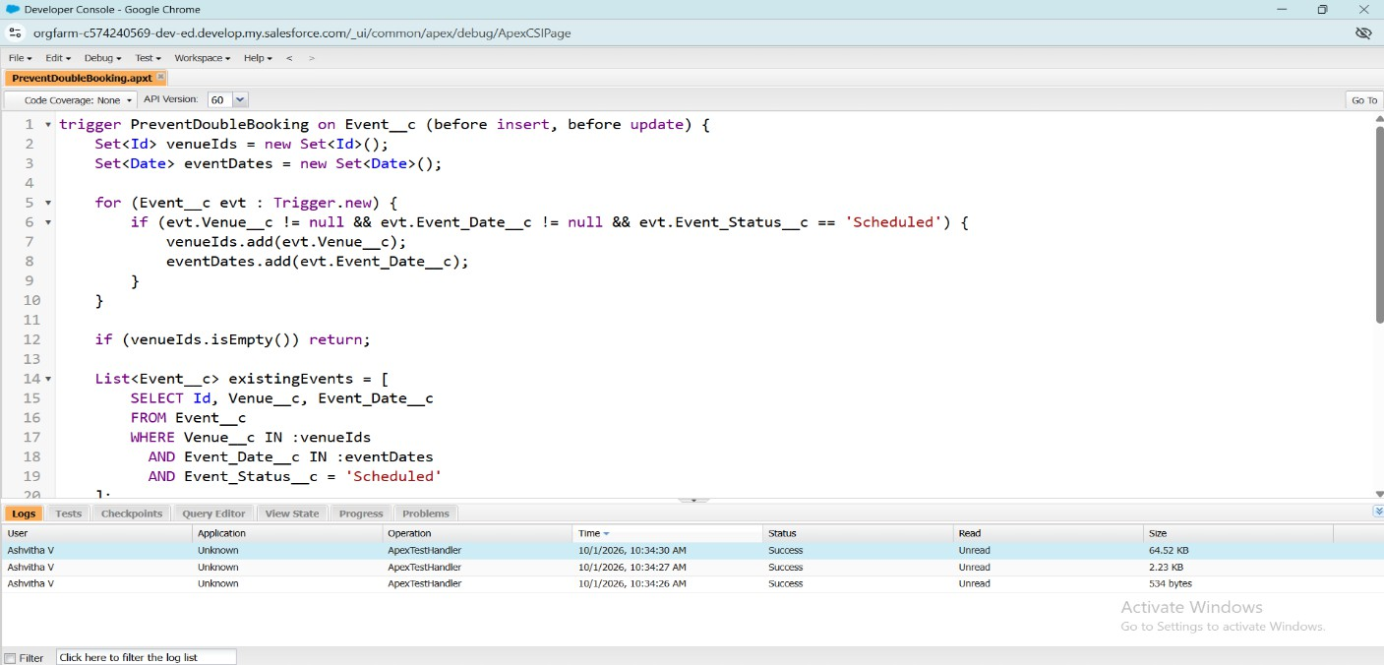

Milestone 10 – Batch & Schedulable Apex
Scenario: mark all past events as Completed every night. A Batch Apex class processes the records in chunks, and a Schedulable class runs the batch automatically.

Batch Class: BatchCompleteEvents
global class BatchCompleteEvents implements Database.Batchable<sObject> { global Database.QueryLocator start(Database.BatchableContext bc){
return Database.getQueryLocator(
'SELECT Id, Event_Date c, Event_Status c FROM Event c ' + 'WHERE Event_Date c < TODAY AND Event_Status c != \'Completed\''
);
}
global void execute(Database.BatchableContext bc, List<Event c> scope){ for(Event c ev : scope){
ev.Event_Status c = 'Completed';
}
update scope;
}
global void finish(Database.BatchableContext bc){ System.debug('Past events marked as Completed');
}
}

Schedulable Class: ScheduleCompleteEvents
global class ScheduleCompleteEvents implements Schedulable {

global void execute(SchedulableContext sc){ Database.executeBatch(new BatchCompleteEvents(), 200);
}
}

Scheduling the Job
- Setup → Apex Classes → click Schedule Apex.
- Job Name: Daily Event Completion; Apex Class: ScheduleCompleteEvents.
- Frequency: Weekly; Days: select all days; Preferred Start Time: 08:00 PM.
- Click Save. The batch now runs every night at 8 PM and marks past events as Completed.
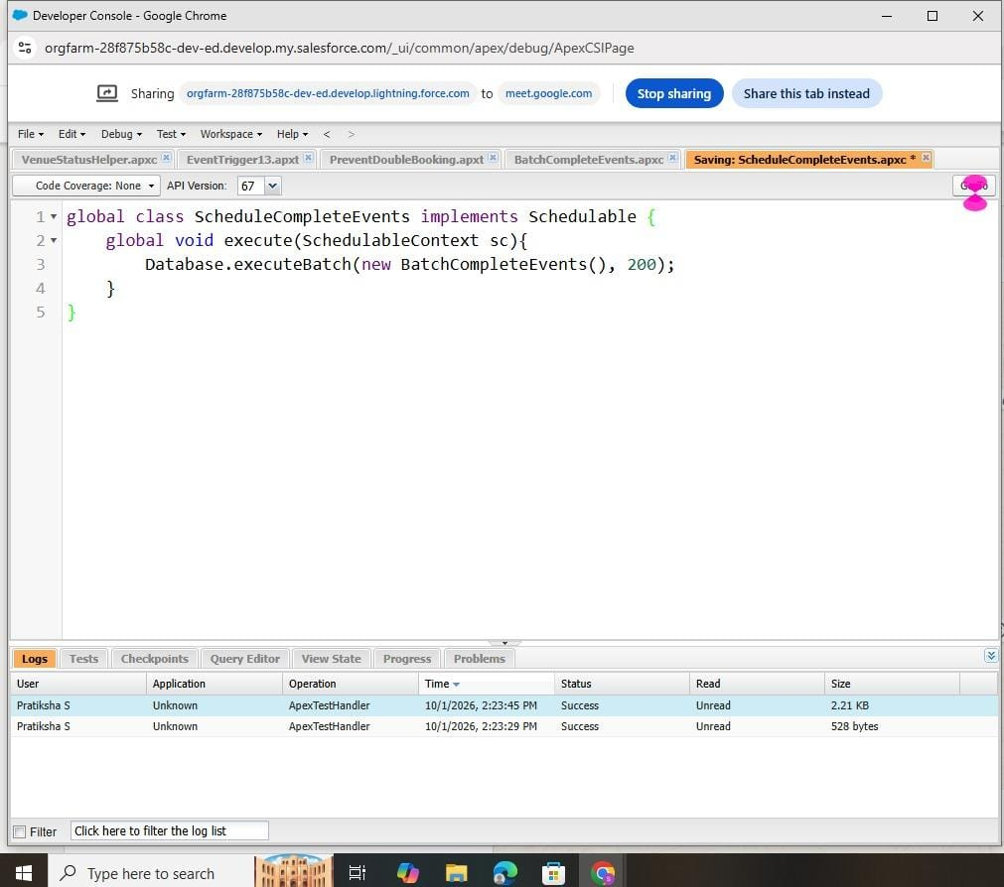

Phase 3: UI/UX Development & Customization
This phase created a simple, user-friendly interface: a custom Lightning App that groups all modules into one workspace, and reports and dashboards that visualize event schedules, vendor performance and client feedback.

Milestone 11 – The Lightning App
An app is a group of tabs that work together as a unit, with a name, a logo and a set of tabs. The Event Planner app was created as follows:
- Setup → App Manager → New Lightning App. App Name: Event Planner; upload an image; click Next.
- Leave App Options and Utility Items at their defaults and click Next.
- From Available Items select Event, Client, Vendor, Venue, Feedback, Reports and Dashboards and move them to Selected Items; click Next.
- From Available Profiles select System Administrator (and other required profiles) and move them to Selected Profiles.
- Click Save & Finish. Verify by opening the App Launcher, searching Event Planner and selecting the app.
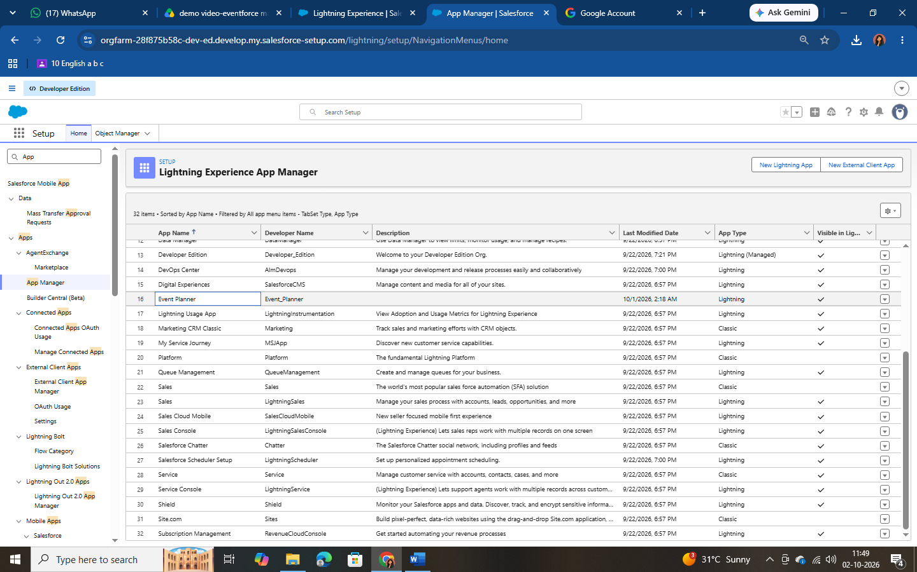

Milestone 12 – Reports

Creating and Sharing the Report Folder
- App Launcher → Reports → New Folder. Folder Label: EventForce Report; click Save.
- From All Folders, open the drop-down on the folder → Share.
- Share with Roles: Event Coordinator and Vendor Manager with View access; click Share, then Done.

Report: Upcoming Events by Month
Purpose: view upcoming events and their counts and budgets by month. At least 10 records were created in every object before building the report.

- Reports → New Report; category All; select Events (or Events with Client & Venue);
Start Report.
- Columns: Event Name, Event Date, Event Type, Client Name, Venue Name, Event Budget.
- Filters: Show Me = All Events; Event Date ≥ TODAY (or Next 30 Days); Event Status ≠ Canceled.
- Group Rows: Event Date → Group by Calendar Month.
- Add Summary: Row Count and SUM of Event Budget.
- Add Chart: Column or Line; X-axis = Event Date (Calendar Month); Y-axis = Row Count or SUM(Event Budget).
- Save as Upcoming Events by Month in the EventForce Report folder and click Run.
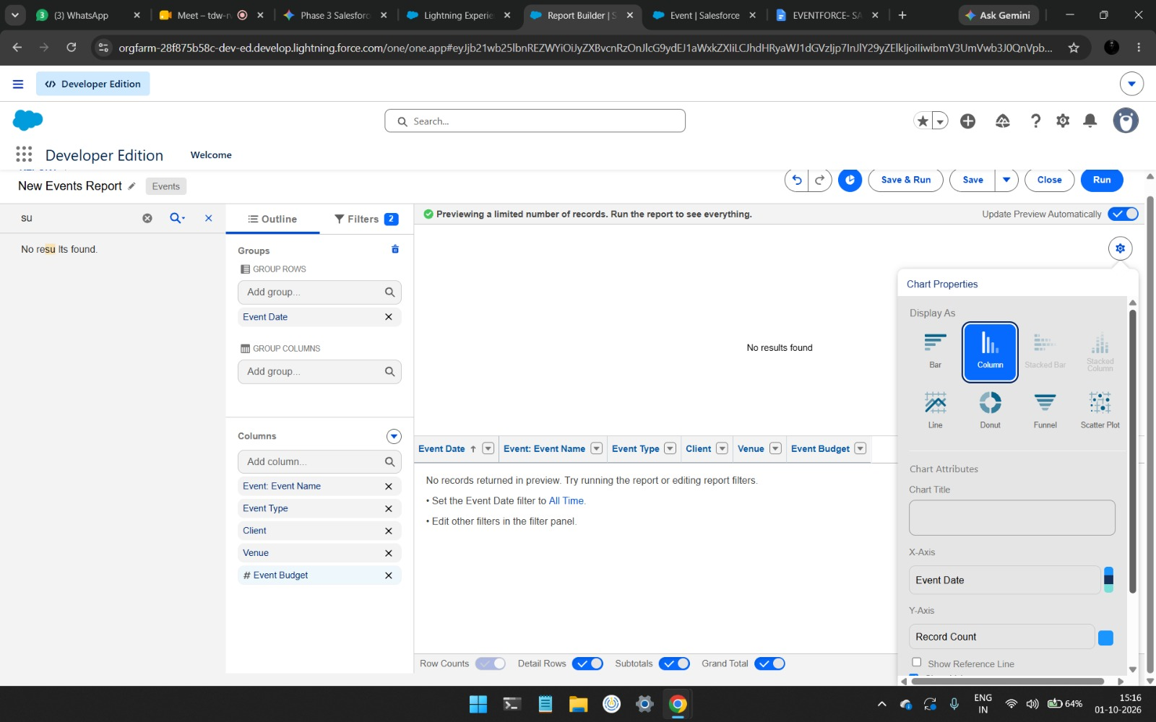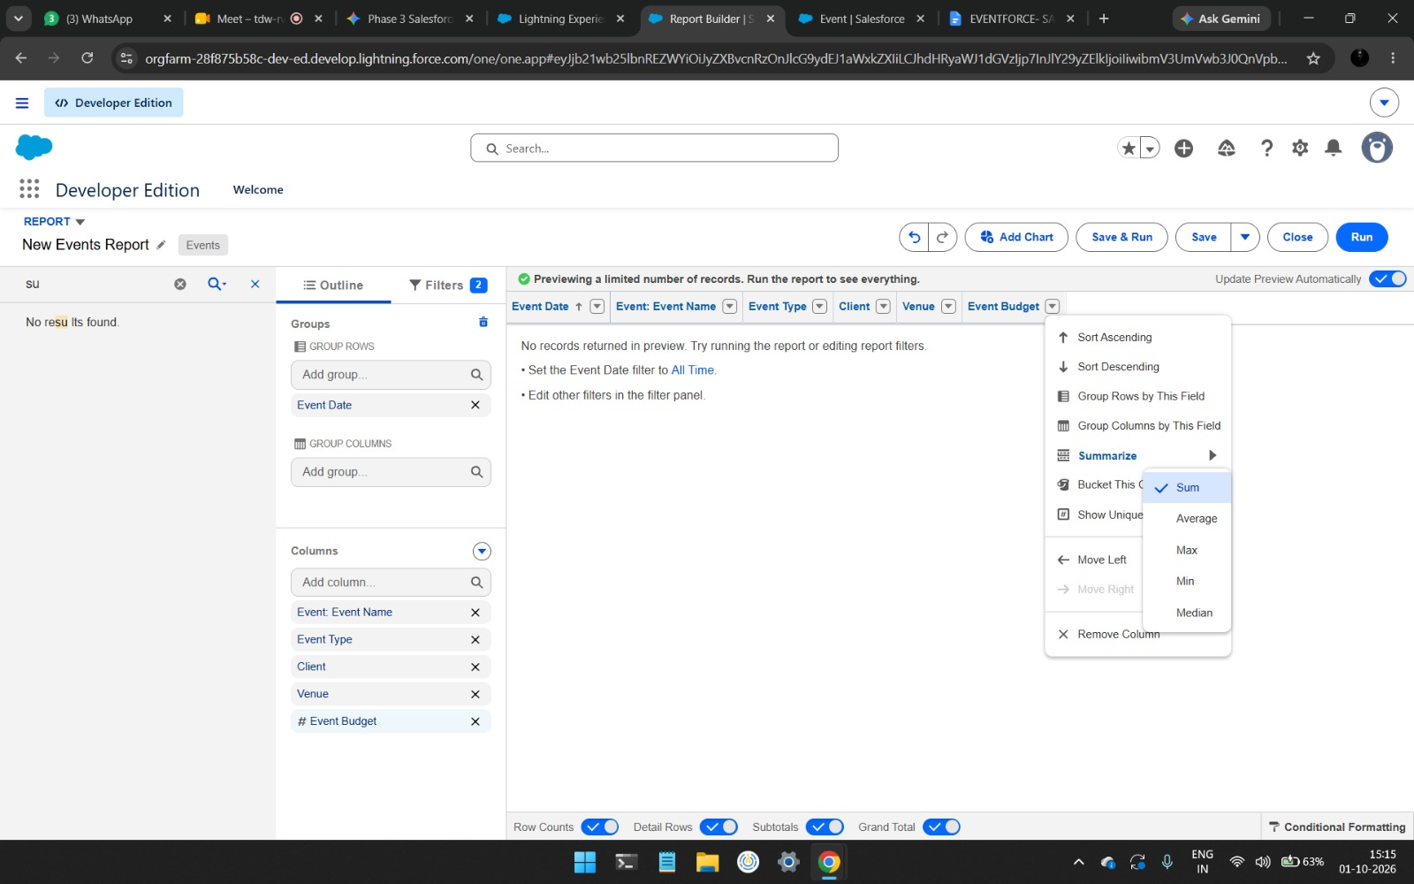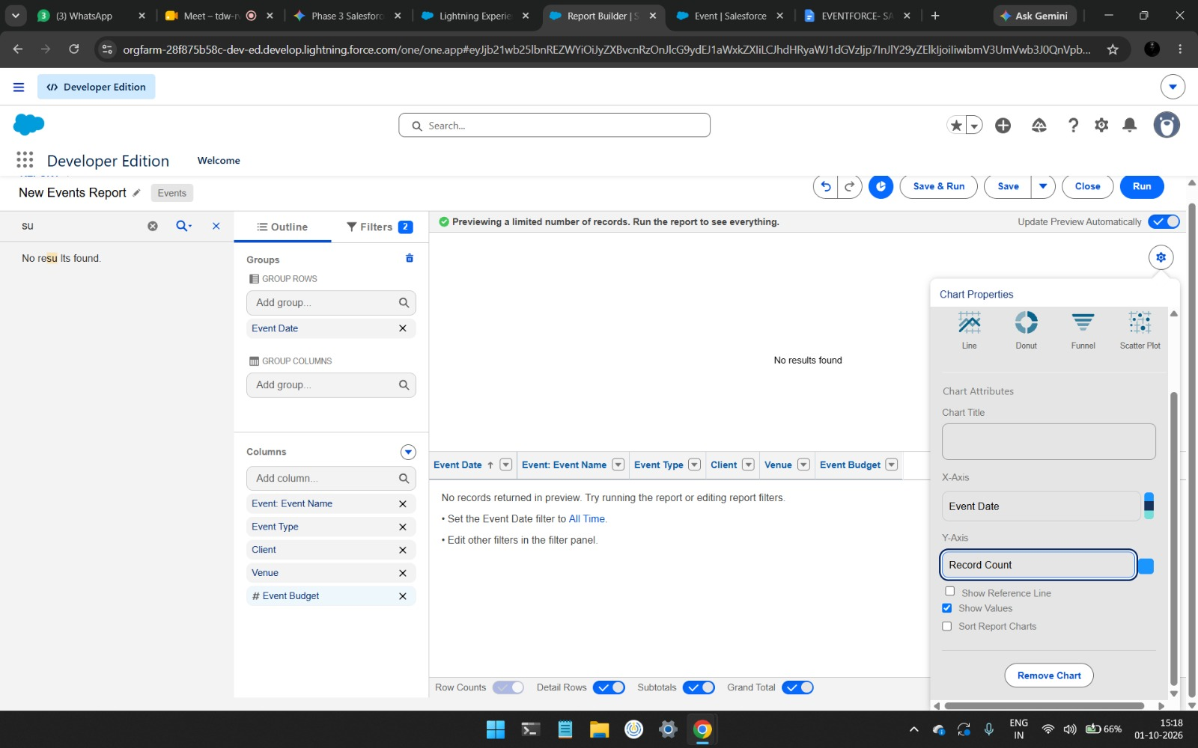
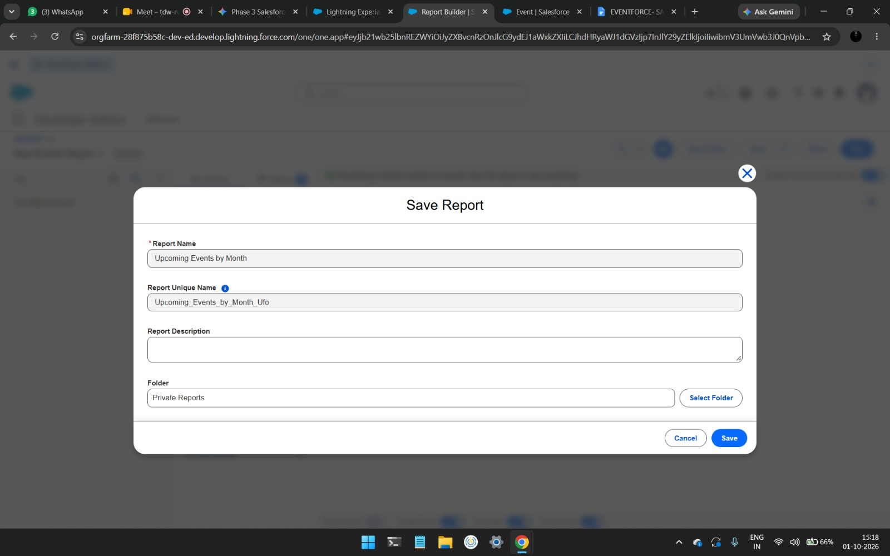

Milestone 13 – Dashboards
- Open the Dashboards tab in the Event Planner app → New Dashboard.
- Name: EventForce Operations Dashboard; click Create.
- Click + Widget and select the Upcoming Events by Month report.
- Chart: Donut; Max Values Displayed: 6; Subtitle: Upcoming Events Overview; Widget Theme: Light.
- Click Save.
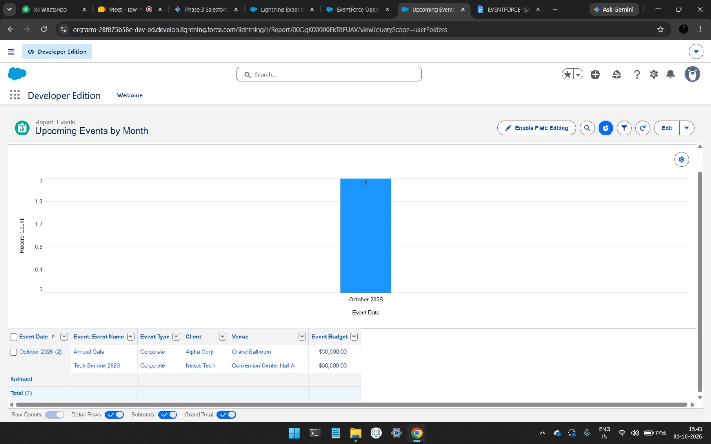
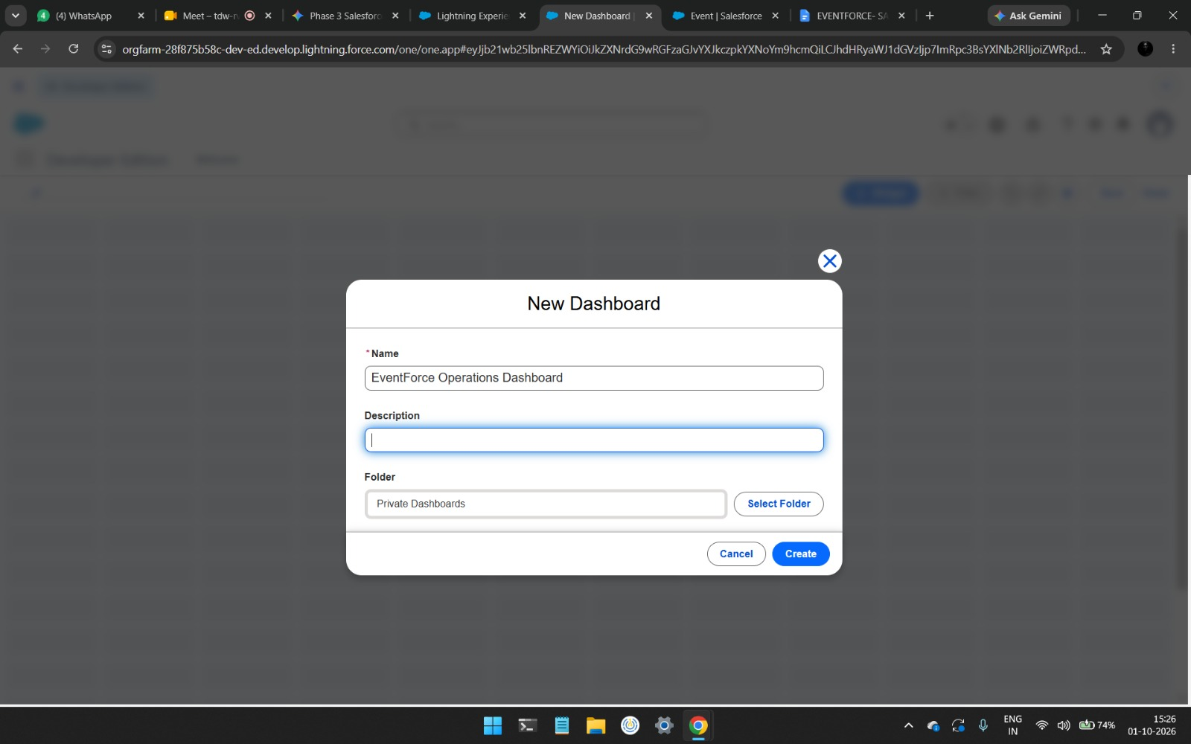

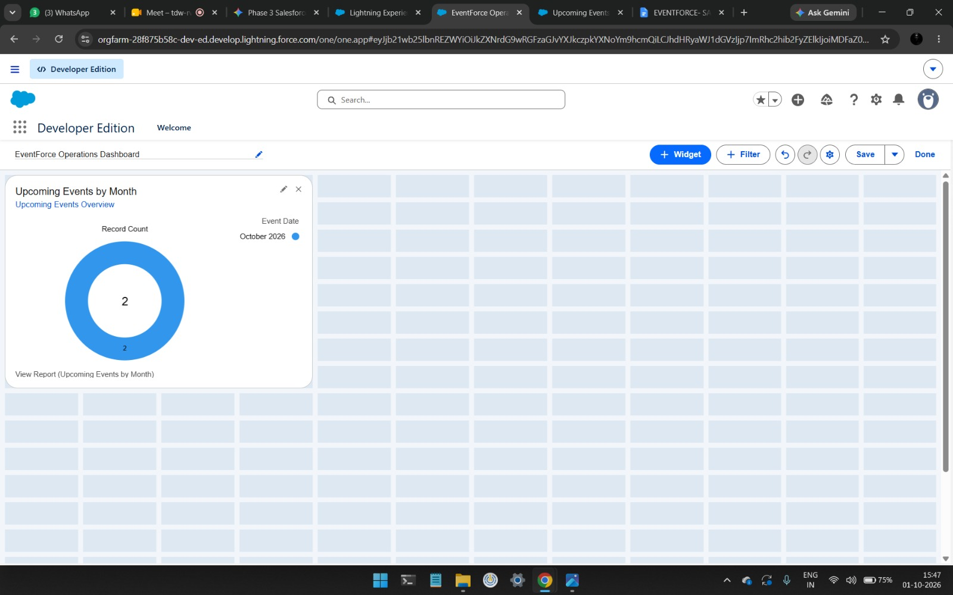

Phase 4: Data Migration, Testing & Security
This phase prepared the system for use by loading validated data, creating users and implementing role-based access control. Records for Events, Clients, Vendors, Venues and Feedback were imported with the Data Import Wizard after pre-validation checks to avoid duplicates. Four types of user accounts (Event Admin, Event Coordinator, Vendor Manager and Client) were created with profiles and roles aligned to their access needs. Organization-Wide Defaults were set to Private and extended by sharing rules.

Milestone 14 – Profiles
A profile is a collection of settings and permissions that define what a user can do in Salesforce (object and field permissions, tab and app settings, login hours, etc.). A user has exactly one profile, but a profile can be assigned to many users.

Event Admin Profile
Created by cloning System Administrator (Setup → Profiles → New Profile → Existing Profile: System Administrator → Profile Name: Event Admin). Cloning provides Modify All Data, Customize Application and full CRUD access on all objects, which suits the administrator role.

Custom Profiles for Other Users
The Event Coordinator, Vendor Manager and Client Profile were each cloned from Standard Platform User, then edited: Custom App Settings → default app set to Event Planner; Custom

Object Permissions set as below; session timeout set to 2 hours of inactivity; password never expires; minimum password length 8.

Object | Event Coordinator | Vendor Manager | Client Profile
Event | Create, Read, Edit, Delete | Read only | Read only (own events)
Client | Read, Edit | Read only | —
Vendor | Read | Create, Read, Edit, Delete | No access
Venue | Read | Read only | No access
Feedback | Create, Read | Read only | Create, Read
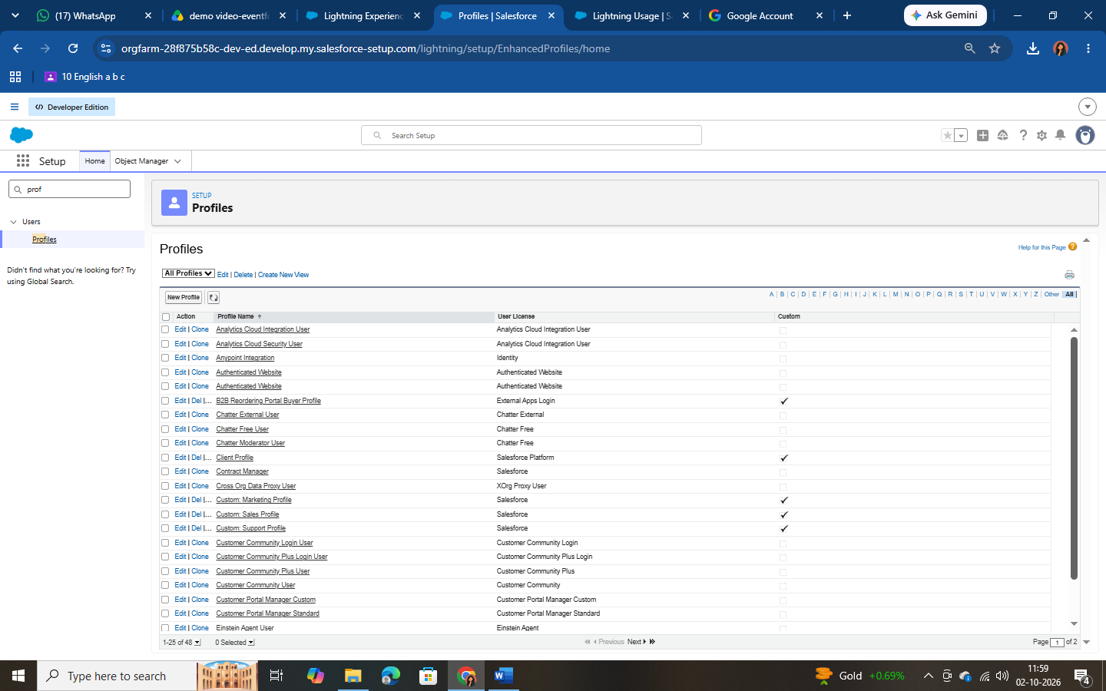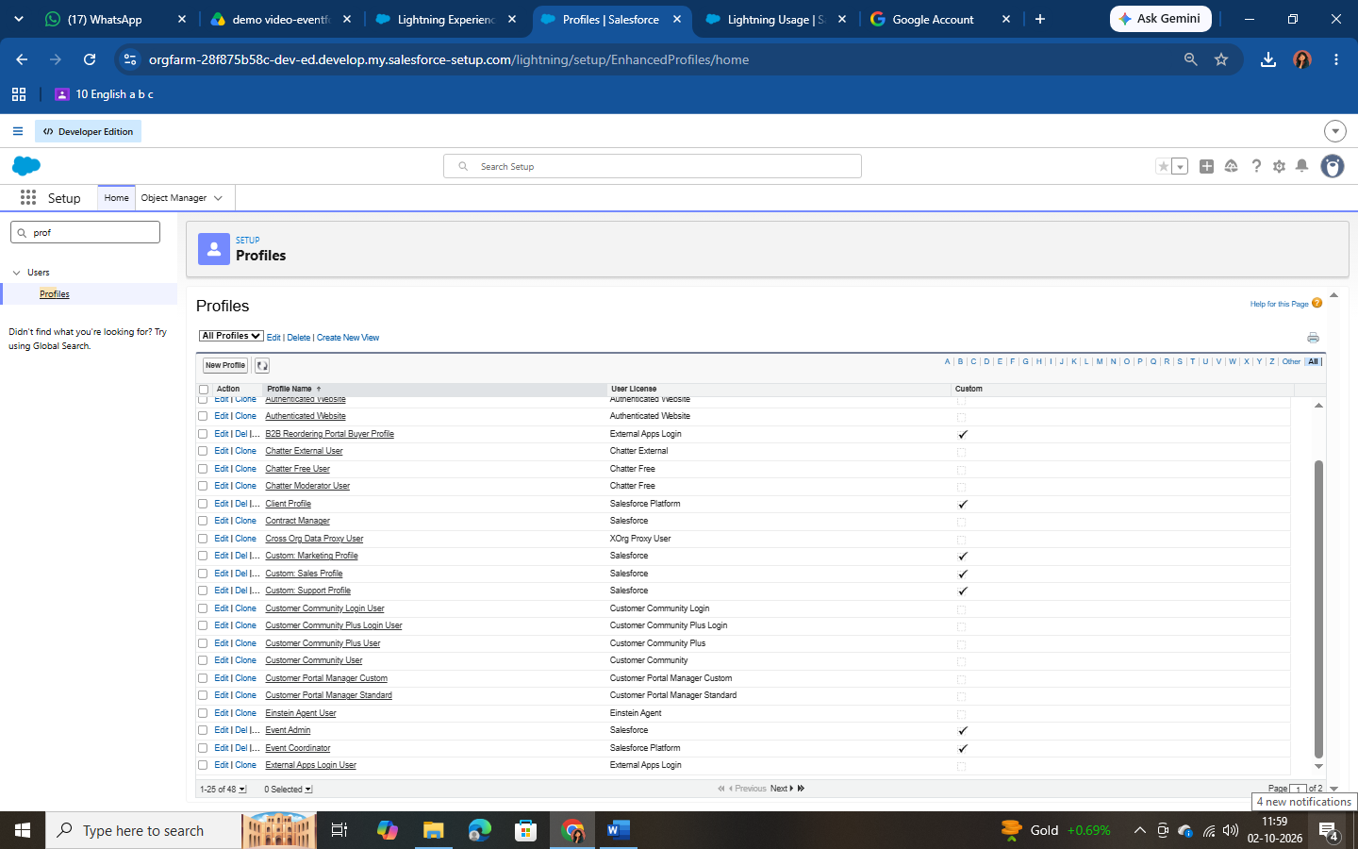

Milestone 15 – Roles
Roles define the reporting hierarchy and determine record visibility upward through the hierarchy. The Event Admin role was created under CEO (Setup → Roles → Set Up Roles → Expand All → Add Role), and three roles were added beneath it.

Role | Reports To
Event Admin | CEO
Event Coordinator | Event Admin
Vendor Manager | Event Admin
Client | Event Admin

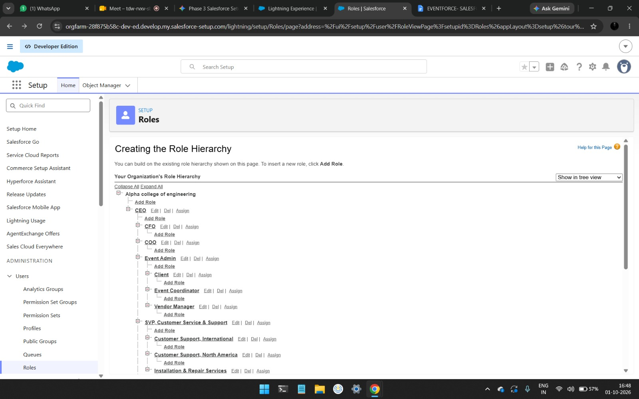

Milestone 16 – Users
A user is anyone who logs in to Salesforce. Users were created from Setup → Users → New User. The first user was created with Role Event Admin, License Salesforce and Profile Event Admin. The other users were created with License Salesforce Platform and the matching Role and Profile.

User Type | Role | User License | Profile
Event Admin | Event Admin | Salesforce | Event Admin
Event Coordinator | Event Coordinator | Salesforce Platform | Event Coordinator
Vendor Manager | Vendor Manager | Salesforce Platform | Vendor Manager
Client | Client | Salesforce Platform | Client Profile
Note: a Developer Edition org has a limited number of Salesforce licenses. If none are available, deactivate an existing user holding that license or change the license type.

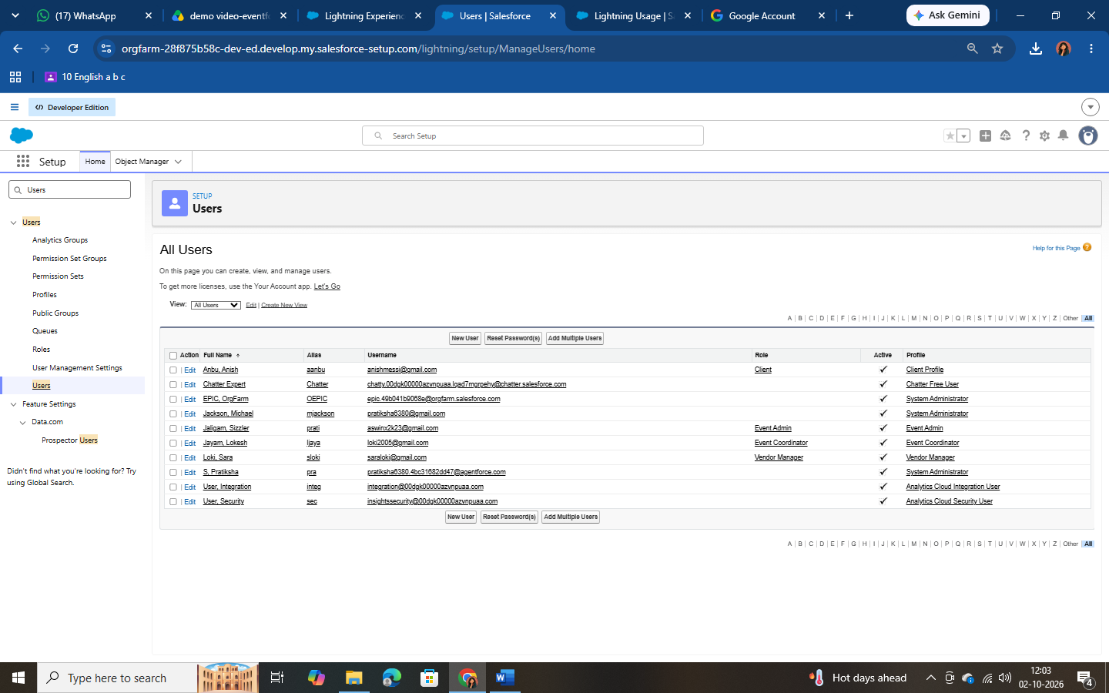
Figure 6.2 – Users

Milestone 17 – Permission Set
A permission set grants extra permissions without changing a user’s profile. A Feedback Manager permission set was created to give selected users full access to the Feedback object.
- Setup → Permission Sets → New. Label: Feedback Manager; click Save.
- Open Object Settings → Feedback → Edit; enable Read, Create, Edit and Delete;
click Save.
- Click Manage Assignments → Add Assignment, select the Event Coordinator user, and click Next → Assign.

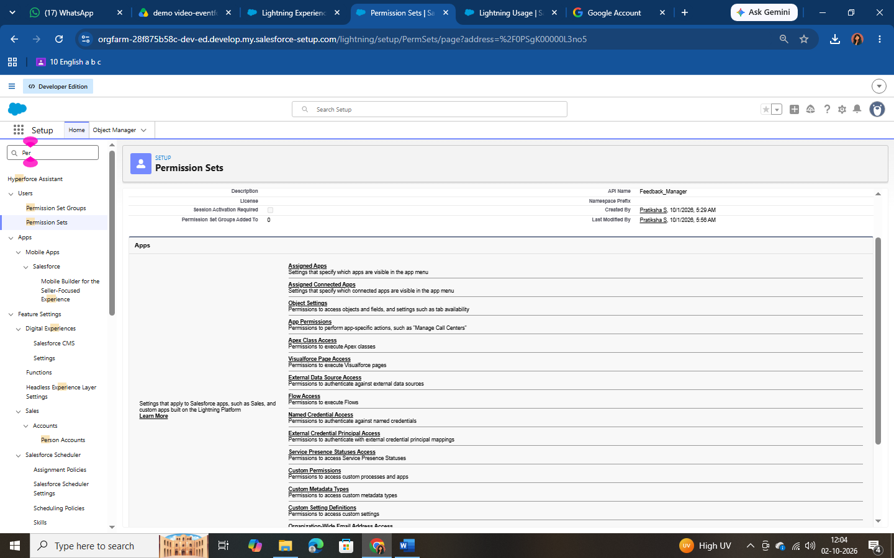

Milestone 18 – Sharing Settings
Organization-Wide Defaults (OWD) set the baseline access to records, which can then be opened up using the role hierarchy, sharing rules, manual sharing or Apex sharing. Sharing rules can only extend access, never restrict it.

Configuring OWD
- Setup → Sharing Settings → Edit (Organization-Wide Defaults).
- For the Event object set Default Internal Access = Private and Default External Access = Private.
- Click Save.

Sharing Rule: Event_Sharing_For_Vendors
- In Sharing Settings find the Event object’s Sharing Rules and click New.
- Label: Event_Sharing_For_Vendors (rule name auto-populates).
- Records to be shared: members of Roles → Event Coordinator.
- Share with: Roles → Vendor Manager.
- Access Level: Read Only; click Save.

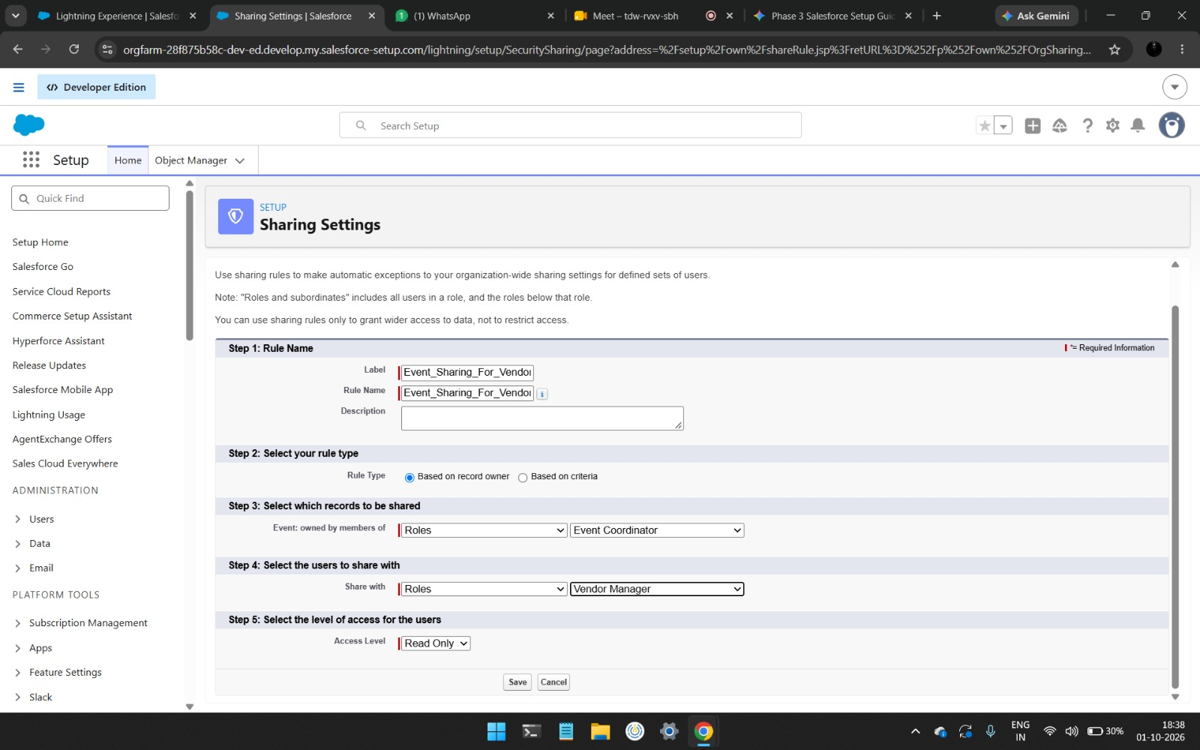

Phase 5: Deployment, Documentation & Maintenance

Deployment Strategy
All configurations, customizations and automations were built and tested within a Salesforce Developer Edition Org. The objective of this phase is to understand how a real-world Salesforce CRM solution is prepared for deployment after configuration, testing and security setup. Actual production deployment is not performed in this project because Developer Edition orgs are standalone and not connected to production instances, and real deployments require sandboxes, change sets or DevOps tooling.
In an enterprise setting, the recommended deployment path would be:
- Develop and unit-test in a Developer or Developer Pro sandbox.
- Promote the metadata (objects, fields, flows, Apex, approval process, reports, dashboards) through a Partial/Full sandbox for UAT using Change Sets or Salesforce DX
/ Git-based CI/CD pipelines.
- Run Apex tests (minimum 75% code coverage is required for production deployment) and validate the deployment.
- Deploy to production during a low-usage window, activate flows, approval processes and scheduled jobs, and assign permission sets.
- Load production data, train users and provide post-go-live support.
Note: Apex test classes were not part of this academic build. Before any production deployment, test classes for VenueStatusHelper, PreventDoubleBooking, BatchCompleteEvents and ScheduleCompleteEvents must be written to meet the 75% coverage requirement.

Maintenance, Monitoring & Troubleshooting
Maintenance keeps event, client, vendor and feedback data accurate and the automations healthy.

Activity | Approach
Monitoring | Regularly review Flow error emails, Apex Jobs and Scheduled Jobs, and pending approvals
Access issues | Resolve user-access errors and permission conflicts by reviewing profiles, permission sets, roles and sharing rules
Debugging | Use Debug Logs and the Developer Console to debug Apex triggers and Flow logic
Rule tuning | Adjust validation rules and sharing settings as business needs evolve
Data quality | Run duplicate checks and periodic data cleansing; review reports for anomalies
Releases | Review Salesforce seasonal release notes and re-test critical automations after each release

Common Issues and Resolutions
Issue | Likely Cause | Resolution
User cannot see the Event Planner app or a tab | Profile or permission set lacks app/tab access | Enable the app/tab visibility in the profile or permission set
Approval process cannot be submitted | No approver/manager configured, or entry criteria not met | Assign a manager on the User record; confirm status is Pending Cancellation
Reminder email not sent | Flow inactive, status not Confirmed, or client email blank | Activate the flow; verify the status and client email
Save blocked on an event | Double-booking trigger fired | Choose a different date or venue
Unable to create a user | No free Salesforce license in the Developer Org | Deactivate an unused user or change the license type

Documentation Summary
This document records the purpose, data model, configuration, automation, security and testing of the EventForce Management System. It covers:
      - Business overview and objectives.
      - Phase-wise implementation: Requirement → Development → UI → Testing → Security.
      - Data model and relationships (Event, Client, Vendor, Venue, Feedback, Event Vendor).
      - Automation components: Flow, Approval Process, Validation Rule and Apex logic.
      - Security model: Profiles, Roles, Permission Sets, OWD and Sharing Rules.
      - Testing results and screenshots of all Salesforce features.
It provides a blueprint for future developers and administrators, supporting consistent development, training and smooth knowledge transfer.

FUNCTIONAL & PERFORMANCE TESTING
During testing, screenshots were captured from Salesforce to validate event creation, venue assignment, double-booking prevention triggers, approval status updates, batch processing, scheduled reminders, and dashboard analytics. All features were verified to ensure correct functionality and performance.
Testing validated data accuracy, automation performance and user permissions. The main test scenarios are summarized below.

# | Area | Test Scenario | Expected Result
1 | Validation Rule | Save a Client with an invalid email (e.g. “abc@”) | Save blocked with “Please Enter Valid Email Address”
2 | Formula Field | Create events of each Event Type | Event Budget auto-populates as per formula
3 | Double Booking | Create two events at the same Venue on the same date | Error: “This Venue is already booked on this date.”
4 | Venue Status | Set an event to Confirmed, then Canceled | Venue becomes Reserved, then Available
5 | Approval Process | Set Event Status to Pending Cancellation and submit | Approval request and alert emails are sent
6 | Approval –  Approve | Approver approves the request | Status = Canceled; owner notified
7 | Approval –  Reject | Approver rejects the request | Status = Rejected; owner notified
8 | Flow | Confirm an event dated 3+ days ahead with a client email | Reminder email is sent three days before the event date
9 | Batch Apex | Run the batch with past-dated events | Past events are marked Completed
10 | Lookup Filter | Select a Client on Feedback, then open the Event lookup | Only that client’s events are listed
11 | Security | Log in as each user type | Each user sees only the tabs, objects and records permitted
12 | Sharing Rule | Vendor Manager views coordinator-owned events | Events are visible as Read Only

ADVANTAGES & DISADVANTAGES

Advantages
- Centralized Data Management – Event, Client, Vendor, Venue, Feedback, and EventVendor information is managed within Salesforce.
- Process Automation – Flows automate reminders and other business processes, reducing manual effort.
- Prevents Double Booking – Apex Trigger and VenueStatusHelper validate venue availability and help prevent booking conflicts.
- Controlled Cancellation Process – Approval Process provides structured handling of event cancellation requests.
- Improved Operational Visibility – Reports and Dashboards provide visibility into event schedules, vendor activities, and feedback.
- Secure Access – Profiles, Roles, Permission Sets, OWD, and Sharing Rules provide controlled access to records.
- Scalable Solution – Salesforce provides a platform that can support future growth and additional business requirements.
- Better Data Quality – Validation Rules and pre-validation during data migration help maintain accurate and consistent data.

Disadvantages
- Developer Edition Limitation – The project was implemented in a Salesforce Developer Edition for academic purposes and was not connected to a production environment.
- Production Deployment Not Performed – Actual migration to production was outside the scope of this implementation.
- Deployment Requires Additional Tools – Real-world deployment may require sandboxes, Change Sets, Salesforce DX, or DevOps/CI-CD tools.
- Configuration Complexity – Managing Flows, Apex, Approval Processes, and security configurations requires appropriate Salesforce knowledge.
- Ongoing Maintenance Required – Flows, Apex jobs, approval processes, validation rules, and sharing settings need regular monitoring and troubleshooting.

CONCLUSION
The EventForce Management System successfully demonstrates how Salesforce can be used to streamline and automate event planning and management operations. The project brings Events, Clients, Vendors, Venues, Feedback, and EventVendor data into a centralized platform.
The implementation combines Salesforce Lightning, Flows, Validation Rules, Formula Fields, Approval Processes, Apex Triggers, Apex Classes, Batch Apex, Scheduled Apex, security controls, Reports, and Dashboards to address key business requirements. Automation supports activities such as event reminders, cancellation approvals, venue availability management, double-booking prevention, and event completion.

The project also demonstrates the importance of data migration, testing, security, documentation, and maintenance in a Salesforce implementation. Although the solution was developed and tested in a Developer Edition Org and actual production deployment was not performed, the project reflects real-world Salesforce implementation practices and provides a foundation for future scalability and enhancement.

Key Learnings
- Designing a scalable data model, including junction objects for many-to-many relationships.
- Combining declarative tools (Flows, Approval Processes, Validation Rules) with Apex for advanced logic.
- Writing bulk-safe Apex triggers and using Batch and Schedulable Apex for asynchronous processing.
- Implementing layered security with Profiles, Roles, Permission Sets, OWD and Sharing Rules.
- Building reports and dashboards that turn operational data into decisions.
- Understanding how a Developer Org build maps to real-world deployment, maintenance and documentation practices.

FUTURE SCOPE
The EventForce Management System can be further enhanced to support larger-scale event operations and improve automation, integration, and user experience.
- Production Deployment – Deploy the solution from development to a production Salesforce environment using appropriate deployment tools.
- Advanced Event Automation – Extend automation for additional event planning and operational activities.
- Enhanced Vendor Management – Introduce more advanced vendor tracking and performance management capabilities.
- Advanced Analytics – Add more reports and dashboards for deeper insights into events, venues, vendors, and client feedback.
- External Integrations – Integrate Salesforce with external systems and services required for real-world event operations.
- Mobile Accessibility – Enhance the solution for convenient event management through mobile devices.
- Scalability Enhancements – Expand the system to support larger numbers of events, clients, vendors, venues, and users.
- Continuous Maintenance & Optimization – Regularly improve Flows, Apex, validation rules, sharing settings, and other configurations as business requirements evolve.
These enhancements can help transform the current EventForce implementation into a more comprehensive and enterprise-ready event management CRM solution.

APPENDIX
- A. Custom Objects: Event, Client, Vendor, Venue, EventVendor, Feedback
- B. Automation: Flows, Validation Rules, Approval Process, Apex Triggers & Classes
- C. Processing: Batch Apex and Scheduled Apex
- D. Security: Profiles, Roles, Permission Sets, OWD, Sharing Rules
- E. Data Migration: Salesforce Data Import Wizard
- F. UI & Analytics: Lightning App, Reports & Dashboards
- G. Testing & Documentation: Configuration testing, security testing, automation testing, and project documentation

Thank You

